«Л.Н.Гумилёв атындағы Еуразия ұлттық университеті» КЕАҚ

ӘОЖ547.829:675.043.84 Қолжазба құқығында

Жумабаева Гулстан Каршыгаевна

Кеуекті бейорганикалық қосылыстарды гликольурил негізіндегі гетероциклдермен модификациялау арқылы жаңа композиттік материалдарды әзірлеу
8D05306 – Химия

Философия докторы (PhD) дәрежесін алу үшін мақалалар топтамасы түріндегі диссертация

Ғылыми кеңесші: химия ғылымдарының докторы, профессор Еркасов Р.Ш.
Шетелдік кеңесші: химия ғылымдарының докторы, профессор Бакибаев А.А.

Қазақстан Республикасы, Астана, 2026

Мазмұны

1 | Methods of Analysis and Identification of Betulin and Its Derivatives | 3-27
2 | Obtaining New Biocompatible Composite Materials with Antibacterial Properties Based on Diatomite and Biologically Active Compounds | 28-48
3 | Effect of Modification of Mesoporous Bioactive Glass with Cucurbit[n]urils (n = 6, 7, 8) on the Structural and Physicochemical Characteristics of Composite Biomaterials | 49-65


molecules

Article

Methods of Analysis and Identification of Betulin and Its Derivatives
Altynaray T. Takibayeva ¹, Gulistan K. Zhumabayeva ², Abdigali A. Bakibaev ³, Olga V. Demets ^{1,}*,
Maria V. Lyapunova ³, Elena A. Mamaeva ⁴, Rakhmetulla Sh. Yerkassov ², Rymchan Z. Kassenov ⁵
and Marat K. Ibrayev ⁵

¹ Department of Chemistry and Chemical Technologies, NJSC Karaganda Technical University Named after Abylkas Saginov, Karaganda 100027, Kazakhstan; altynarai81@mail.ru
² Faculty of Natural Sciences, L.N. Gumilyov Eurasian National University, Astana 010000, Kazakhstan; gulistan2009@mail.ru (G.K.Z.); erkass@mail.ru (R.S.Y.)
³ Chemical Faculty, National Research Tomsk State University, 634028 Tomsk, Russia; bakibaev@mail.ru (A.A.B.); lyapunova.mari@mail.ru (M.V.L.)
⁴ Chemical Faculty, National Research Tomsk Polytechnic University, 634050 Tomsk, Russia; mamaeva.elena@mail.ru
⁵ Department of Organic Chemistry and Polymers, Chemistry Faculty, NJSC Karaganda University Named after Y.A. Buketov, Karaganda 100024, Kazakhstan; r_z_kasenov@mail.ru (R.Z.K.); mkibr@mail.ru (M.K.I.)
* Correspondence: sweetc7@mail.ru; Tel.: +7-708–903–9236


Citation: Takibayeva, A.T.; Zhumabayeva, G.K.; Bakibaev, A.A.; Demets, O.V.; Lyapunova, M.V.; Mamaeva, E.A.; Yerkassov, R.S.; Kassenov, R.Z.; Ibrayev, M.K. Methods of Analysis and Identification of Betulin and Its Derivatives. Molecules 2023, 28, 5946. https://doi.org/10.3390/ molecules28165946
Academic Editor: Josef Jampilek

Received: 30 June 2023
Revised: 21 July 2023
Accepted: 30 July 2023
Published: 8 August 2023

Copyright: © 2023 by the authors. Licensee MDPI, Basel, Swiderland. This article is an open access article distributed under the terms and conditions of the Creative Commons Attribution (CC BY) license (https:// creativecommons.org/licenses/by/ 4.0/).
Abstract: This scientific work presents practical and theoretical material on the methods of analysis and identification of betulin and its key derivatives. The properties of betulin and its derivatives, which are determined by the structural features of this class of compounds and their tendency to form dimers, polymorphism and isomerization, are considered. This article outlines ways to im-prove not only the bioavailability but also the solubility of triterpenoids, as well as any hydropho-bic drug substances, through chemical transformations by introducing various functional groups, such as carboxyl, hydroxyl, amino, phosphate/phosphonate and carbonyl. The authors of this arti-cle summarized the physicochemical characteristics of betulin and its compounds, systematized the literature data on IR and NMR spectroscopy and gave the melting temperatures of key acids and aldehydes based on betulin.
Keywords: betulin; the solubility of pentacyclic triterpenoids; bioavailability; chemical transformation

Introduction
Biologically active compounds based on plants and products of their chemical trans-formation are used as food additives to maintain and promote a healthy lifestyle, prevent diseases and treat ailments. The nutritional value and pharmacological effect of such drugs primarily depend on their chemical composition, which is complex and multicomponent in nature, which is accompanied by difficulties in isolating, analyzing and identifying the main components and in their rationing.
Among the many extractive substances from plant raw materials, pentacyclic triter-penoids from birch bark, especially betulin (1) and related compounds (2–9), occupy a special place. Betulin (1) and betulinic acid (5), as a result of a number of chemical trans-formations, lead to highly active derivatives, some of which are comparable to clinically used preparations [1,2], and the content of betulin overwhelmingly predominates the con-tent of betulinic acid in the native extract [3]. Moreover, betulin and betulinic acid are valuable matrices for many semisynthetic derivatives that are potentially more effective drugs [2,4–8]. Betulin exhibits many other biological effects (anti-inflammatory [9,10], an-tiviral (including anti-HIV), etc.) [6,11–18], including the antimycotic and antimicrobial activities mentioned above. Betulin also inhibits cholesterol and fatty acid biosynthesis and thus reduces diet-induced obesity. This compound reduces the size and improves

Molecules 2023, 28, 5946. https://doi.org/10.3390/molecules28165946 https://www.mdpi.com/journal/molecules

the stability of atherosclerotic plaques (as evidenced by the reduction in macrophage ac-cumulation) [19]. The authors of [19] also recommend its use in the treatment of type II diabetes by activating the sensitivity of cells to insulin. Pentacyclic triterpenoids can be used and developed as new drugs with a wide clinical effect [4,6]. There have been new reports [20–24] on the biological properties of betulin and its derivatives in recent years.
Thus, high-purity betulin (1) is widely used for the production of pharmaceutical and cosmetic products and biologically active additives. Betulin and its semisynthetic deriva-tives have a very high potential for use mainly in medicine [16,18].
Betulin (1) can actually be considered the first biologically active substance extracted from a plant source on an industrially significant scale [25]. Currently, it is considered that the outer bark of birch (birch bark) is rich in such pentacyclic triterpene compounds such as betulin (lup-20(29)-en-3β,28-diol), lupeol (lup-20(29)-en-3-ol), betulinic acid (3β-hydroxy-20(19)-lupaene-28 acid) and other minor components (oleanolic acid, urso-lic acid and betulin aldehydes) [18]. It is generally assumed that birch bark is the area of bark exiting from the last formed layer of the periderm to the outermost surface of the tree [26].
Betulin (1) is found in warty birch or hanging birch (Betula verrucosa Ehrh. or Betula pendula Roth.) and fluffy birch (Betula pubescens Ehrh.), the most widespread in Russia and in the Northern hemisphere [27]. Betulin (1) is also found in the birch bark of white birches (Betula alba) growing in Europe [28]. The main source of betulin is birch bark [29–31], although betulin (1) has been found in at least two dozen plants belonging to var-ious genera and families. For example, betulin (1) is found in hazel bark, calendula and other medicinal plants. For example, betulin, lupeol and betulinic acid are extracted from the bark of alder cordial (Alnussubcordata L.) [32], unabi vulgaris (Ziziphus jujube M.) [33,34] as well as from the ground part of thistle (Atractylis carduus L.) [35]. Betulinic acid is found in the leaves of plumeria (Plumeria obtusa) [36], triadenum (Triadenum japonicum) [37], or-chid (Orchid lusiaindivisa) [38] and other plants (Dillenia papuana, Tryphyllum peltatum, An-cistrocladus heuneaus, Diospyrus leucomelas, Tetracera boliviana, Sizyphus joazeuro, Syzigium claviflorum, Aerua javanica) [39,40].
  - General Information about Betulin and Its Derivatives
Betulin is a natural pentacyclic triterpenoid belonging to the lupan group and has a systematic name–3β,28-dihydroxy-20(29)-lupen or lup-20(29)-en-3β,28-diol (Figure 1).



29
20
30
19 21
12
18
E
25
11
C
26 13
14 D 16
17
2
3
1
A
4
10
9
15
8
5 B 7
6
27 1

22
28
CH₂OH

HO
24 23
Figure 1. The structural formula of betulin (1) (3β,28-dihydroxy-20(29)-lupen or lup-20(29)-en-3β,28-diol).
The structure of the lupane series triterpenoids is based on a complex polycyclic sys-tem with a cyclopentaneperhydrophenanthrene (sterane) core consisting of four cyclohex-ane and one saturated cyclopentane ring condensed together. The rings have the designa-tions A, B, C, D and E in accordance with the accepted numbering of the carbon skeleton

atoms and the increasing numbers of carbon atoms (Figure 1). The presence of the five-membered ring E and an α-isopropenyl group in the C-19 carbon atom is characteristic of the betulin (1) belonging to this group [41].
Birch bark has two clearly distinguishable parts—outer and inner. The outer part of the bark is the richest in extractive substances. The main component of almost all extracts is betulin (1), which causes the white color of the bark. Lupeol (2) is a constant companion of betulin during its isolation (Figure 2). Birch bark extracts also contain, along with betulin (1), its oxidized derivatives: betulin aldehyde (3), betulonic aldehyde (4), betulinic acid (5), betulinic acid methyl ester (6) and 3-oxobetulinic (betulonic) acid (7) (Figure 2).

Figure 2. The structural formulas of related substances 2–7 when betulin (1) is extracted from birch bark.
The chemical composition of the bark of many birch species, namely Betula pendula Roth. (B. Verrucosa Ehrh.), Betula pubescens Ehrh. (B. alba L.) and B. davurica Pall., has been studied in sufficient detail [42]. The content of betulin in the outer bark varies from 10 to 40% depending on the type of birch, the place and conditions of its growth, the age of the tree, the season and other factors [30,43,44]. The variety of properties of betulin is determined by the origin of this substance: plants synthesize betulin to protect against all adverse environmental factors and accumulate it exclusively in their shell. Betulin is a nec-essary part of plant shells to protect the plant from damaging environmental factors such as radiation, bacteria, fungi, viruses and insects. The reliability of the protective properties of birch bark is evidenced by the fact that it has been preserved without rotting in the soil for more than 1000 years, as evidenced by Novgorod birch bark certificates.
Betulin (1) is an odorless white crystalline powder with amorphous properties. The use of most solvents does not allow the growth of large crystals, which is a consequence of the presence of a large number of low-polar alkyl lipophilic fragments in the betulin molecule. At the same time, betulin (1) has one double bond and two hydroxyl groups in the molecule: primary and secondary. Both are associated with alkyl fragments and exhibit classical alcoholic properties. Therefore, betulin has a greater affinity for medium-polarity solvents than for low-polar solvents. The molecular weight of betulin (1) is 442.72 g/mol, the gross formula is C₃₀H₅₀O₂ and the melting point is 261 ◦C, [α] +20 ◦C (in pyridine) [29,45], 258 ◦C (according to Gausman) [46]. This compound is resistant to oxygen and sunlight and is non-toxic. Betulin (1) does not occur in its free form [47]. Betulin (1) is quite inert—it does not dissolve with water; when isolated, it crystallizes into whitish pris-matic crystals. It is relatively well soluble in boiling alcohols, ether, chloroform, benzene, pyridine, tetrahydrofuran and dimethyl sulfoxide [46]. The solubility of betulin decreases in alcohol solvents in the following series: 1-butanol > 1-propanol > ethanol > 1-pentanol
> 1-hexanol > methanol. The solubility of betulin in esters decreases in the following de-creasing order: ethyl acetate > methyl acetate > ethyl formate = methyl formate [48].
Betulin is characterized by its low solubility in nonpolar organic solvents [49,50]. Nev-ertheless, the range of solubility of betulin in various solvents should be noted; for example,

the solubility of betulin in acetone (polar) is 5.2 g/L, and in cyclohexane (nonpolar), it is only 0.1 g/L at 15.2 ◦C, and at 35.2 ◦C, the solubility is 13.7 g/Land 0.67 g/L, respectively.
The comparison of the results [51] obtained for two types of solvents shows that non-polar solvents have a number of advantages over their polar counterparts. Nonpolar sol-vents do not form solvates compared to polar solvents after recrystallization. The betulin molecules in polar solvents form hydrogen bonds with each other in addition to forming hydrogen bonds with solvent molecules [51].
Birch bark contains oleanane and ursan triterpenes along with lupan derivatives. Oleic acid and its derivatives predominate in some birch species, for example, in the black-crowned birch (Betula dahurica Pall.) [25,52].
The product of betulin rearrangement, allobetulin (8) (Figure 3), should be noted out of the other oleane derivatives found in birch bark extracts. Allobetulin (8) is easily ob-tained under the action of acidic agents [22].
Figure 3. The structural formula of allobetulin (8).
The qualitative composition of the triterpenoids of the bark of black-backed birch Be-tula pubescens is the same as that of white-barked, but their quantity is 2–3 times less. At the same time, the content of betulin (1) in white- and black-barked Betula pubescens is sig-nificantly lower than in the bark of Betula pendula [53]. The main component of birch bark extract in all cases is betulin (1) (Figure 4).
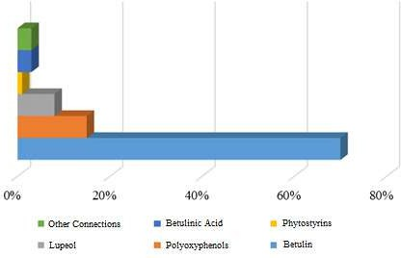
Figure 4. The composition of birch extract.
Extracts of the inner bark of birch contain a small amount of betulin (1); however, they can be used as a source of phenolic compounds for certain purposes [27]. But, at the same time, the total extract of isolated triterpenoids from the inner bark of birch primarily includes betulin (1) (60–85% of the composition), as well as the currently well-studied lu-peol, lupenone, uveol, betulin acetate, allobetulin, isobetulenol, oleanolic acid and others. The physicochemical properties of the above satellites of betulin are close to their progen-itor (1).

  - Structure and Physico-Chemical Properties of Betulin and Its Derivatives
The properties of betulin (1) and its derivatives are largely determined by the struc-tural features of this class of compounds and their tendency toward dimer formation, poly-morphism and isomerization. Betulin (1) is a triterpene alcohol of the lupane series in which cyclohexane rings are in the “chair” conformation and the cyclopentane ring is in the “half-chair” conformation (Figure 5).
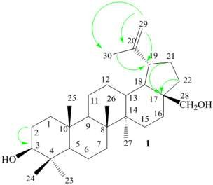
Figure 5. The conformational state of betulin (1). Green arrows show the interaction and mutual arrangement of which atoms and functional groups determine the geometry of the betulin molecule.
The spin-spin interaction constants observed in the ¹H NMR spectra confirm the con-formation of the “chair” of the six-membered betulin (1) rings. In addition, the geometry of the betulin molecule is determined by the location of hydrogen atoms and functional groups attached to the main nucleus: α- or β-orientation in space and α- and β-epimers at the C-3 position [54]. The hydroxyl group at C-3 in the equatorial position (β-OH) gives the betulin molecule greater thermodynamic stability than in the axial position (α-OH) since there is intensity in the α-position due to the repulsion of neighboring atoms.
The combination of these causes gives betulin (1) conformational lability (thermody-
namic instability), which depends on the chemical and physical properties of the medium. Moreover, there are changes in the structure of not only the site in contact with another molecule but also the conformational state of betulin (1) as a whole. In addition, confor-mational lability determines the conformation of the “chair” of cyclohexane cycles, which are displaced relative to each other. Transannular interactions between unbound hydro-gen atoms reduce the stability of the molecule, especially when the atoms are close to each other. Conformational lability also arises due to the mobile structure of the connection of cycles, the presence of four angular methyl groups, two hemdimethyl groups and termi-nal methylene group. In addition, betulin (1)-like related triterpenoids are sensitive to the effects of various factors causing the migration of methyl groups and protons between cy-cles. The discussed structural features of betulin (1) and its derivatives (2–8) cause not only high lability but also the theoretically possible existence of optical isomers and epimers as well as the ability to isomerize.
Intermolecular interactions of two thermodynamically unstable betulin (1) molecules cause various rearrangements and migrations of methyl or hydroxyl groups and also de-termine the most important physico-chemical properties of betulin (1) and its derivatives (2–8), including solubility. Intermolecular interactions, including both hydrophobic bind-ing and the formation of H-complexes with organic solvents in triterpenoid molecules in the solid phase, lead to various polymorphic and solvatopolymorphic forms. Thus, the solvate of betulin (1) with ethanol in a composition of 1:1 has a rhombic syngony in the spatial group P212121, Z = 4. Betulin molecules are connected to each other and to ethanol molecules by hydrogen bonds; as a result of this, layers perpendicular to the crystallo-graphic direction c are distinguished in the structure. All molecules are connected by hydrogen bonds inside the layer, and only Van der Waals interactions exist between the layers [51].

The most stable polymorphic form is the most energetically favorable under certain crystallization conditions, and the more ordered one usually has the worst solubility. Metastable solvatopolymorphs, although they have better solubility, can be toxic due to the presence of solvent molecules in them.
The formation of betulin dimers and inclusion complexes is probably explained by the desire to adopt an energetically favorable form characterized by a minimum of free energy due to hydrophobic interactions and Van der Waals forces of closely connected atoms (Figure 6).
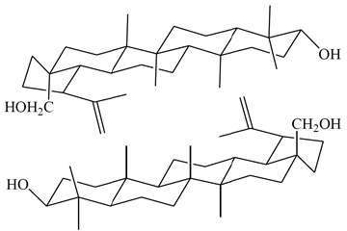
Figure 6. The dimeric structure of betulin (1).
The pseudopolymorphic forms (solvates) are isolated from solvents of different polar-ities during the crystallization of betulin (1), which, according to X-ray diffraction analysis, are inclusion complexes. Studies of the XRD patterns of betulin solvates and its derivatives with various solvents were carried out in [55–61]. Analysis of these data suggests that they have a clathrate-type structure. Since solvents enter the betulin crystal lattice and bind to betulin molecules in a certain way, the most stable are betulin (1) solvates with butanol, ethyl acetate, chloroform and dichloromethane. Betulin solvates recrystallized from ace-tone, methanol, ethanol and propanol are unstable and lose solvent when stored even at room temperature. In general, the crystallization of betulin and its derivatives is the most favorable of alcohol solvents with greater polarity because it does not change its structure. The crystal structure of betulin solvates is stabilized due to hydrogen bonds [53,62], and in this state, they can have independent pharmacological significance.
In general, the existence of unstable solvates and solvatopolymorphs or other poly-morphic forms is a big problem in the pharmaceutical industry since such samples of poly-morphs are usually able to change over time, sometimes completely disappearing and turn-ing into another polymorphic form with lower solubility.
Information on the solubility of betulin and its derivatives in various media is scat-tered and contradictory [50]. More in-depth research on the interaction of betulin with solvents has appeared only recently, and it is claimed that its solubility in pure organic solvents increases with increasing temperature.
Thus, it was found that the solubility of betulin in mixtures of acetone–water and ethanol–water increases with increasing temperature and the predominance of acetone or ethanol in the composition. The solubility of betulinic acid is 3 × 10^{–3} g/L [63], but it is not indicated for which polymorphic form it is determined. The water solubility lies in the range of 2.5 ± 0.5 g/L for most of the close triterpenoids. In the same work [63], the lipophilicity value Log Pow for betulin and lupeol is indicated, where Pow is the distribu-tion coefficient between octanol and water, calculated in the ChemAxon program but not established experimentally. The lipophilicity value Log Pow is very large and is equal to
6.17 and 7.45 for betulin (1) and lupeol (2), respectively. The lipophilicity of triterpenoids characterized by Pow under the assumption that octanol has a lipophilicity similar to cell membranes is used as one of the indicators of drug absorption during passive diffusion. Compounds with low solubility in water and high Log Pow will be distributed more slowly from the cell membrane to the extracellular fluid (transcellular pathway) [64].

Thus, there are difficulties in stabilizing the structure and problems with dissolution and, accordingly, bioavailability, as well as the creation of injectable dosage forms for be-tulin and its derivatives. These compounds are an exception to the “rule of five” [65] and are capable of interaction both due to hydrogen bonds and hydrophobic binding, which leads to the formation of dimers (Figure 6), dense crystal packing arrangements and poly-morphism.
  - Techniques for Increasing the Solubility of Pentacyclic Triterpenoids
One of the significant hindrances to conducting complex physico-chemical studies and effectively demonstrating the biological activity of the studied compounds is their limited solubility. The solubility and bioavailability of hardly soluble pentacyclic triter-penoids can be improved by various colloidal chemical approaches and by introducing hydrophilic groups through chemical modification, as shown for betulin (1) and its deriva-tives.
    - Increasing the Solubility of Pentacyclic Triterpenoids Using Colloidal Chemical Approaches
There are a number of colloidal chemical techniques that allow us to increase the sol-ubility of betulin (1) and its derivatives:
- The nanostructured introduction of betulin and its derivatives into liposomes and other nanoscale compounds [66,67]. Vesicles or liposomes from aqueous dispersions containing lecithin (for example, phosphatidylcholine) and triterpenoid dissolved in DMSO or alcohol are the most studied [68]. Nanoparticles with some betulin deriva-tives are obtained from polymers, while the most promising is an easily degradable copolymer of lactic and glycolic acids (PLGA) [67].
- The micelle formation of betulin and its derivatives with high-molecular compounds in which the polymer acts as a delivery vector [69,70].
- The use of physical principles for betulin and its derivatives (ultrasonic exposure, mechanochemical activation, etc.) in the presence of polymers (polyvinylpyrrolidone, polyethylene glycol, arabinogalactan, etc.) [71,72], which finds a positive effect in the demonstration of biological activity.
- The formation of supramolecular systems (inclusion complexes) [73] due to the com-plexation of betulin and its derivatives with γ-cyclodextrin, glycyrrhizic acid and other compounds capable of forming inclusion complexes by hydrophobic binding [73,74]. An analysis of such inclusion complexes showed, firstly, that the “guest” molecule is located in the cavity between the outer lipophilic sides of two betulin molecules. Secondly, betulin molecules are interconnected by hydrogen bonds so that in the crystal structure of the complex, there are dimers in which betulin molecules are connected by hydrogen bonds of the “head to tail” type (Figure 6). Individual betulin (1) in the crystal probably exists in the form of hydrogen-bound dimers of the “head to head” type, which, based on the data of vibrational spectra and X-ray diffraction analysis, is characterized for organic molecules [75]. Complexes including betulin and its derivatives with cyclodextrins in water dissociate into cyclodextrin and the active substrate, showing the biological properties of the latter [75–78].
The authors [73] showed the formation of host–guest complexes of betulin and its derivatives (allobetulin (8), betulinic acid (5), 3-ketobetulinic acid (7) with pyrazoles). Pre-viously, complexes of betulin diacetate with metamizole sodium (1-phenyl-2,3-dimer-4-methylaminopyrazolone-5-N-methanesulfonate sodium) of the composition 1:1 were ob-tained. It can be assumed that with an optimal choice of reagents, it is possible to syn-thesize host–guest complexes with betulin (1) having the necessary hydrophilic–lipophilic ratio.
Triterpenoids are grafted onto polymers to create water-soluble polymer constructs. According to this approach, a terpene-containing monomer is usually obtained at the first stage, which is then introduced into radical copolymerization. For example, when betulin

interacts with maleic acid in the presence of dicyclohexyl peroxidicarbonate at room tem-perature, the resulting monomer 28-O-betulin maleate copolymerizates with N-vinylpyrrolidone, acrylonitrile and vinyl acetate in the presence of radical initiators. The obtained polymers exhibit higher activity against RD TE32 rhabdomyosarcoma culture compared to betulin maleate [79].
Thus, it can be noted that increasing the bioavailability of betulin and its derivatives using colloidal chemical approaches, expressed in the production of various nanoparticles, both vesicular and micellar, is promising, although it does not solve the problem of suffi-cient solubility of lupan-type triterpenoids.
    - Increasing the Solubility of Pentacyclic Triterpenoids by Chemical Modification of Betulin Improving not only the bioavailability but also the solubility of triterpenoids, as well
as any hydrophobic medicinal substances, can be achieved by chemical transformations
by introducing various functional groups, such as carboxyl, hydroxyl, amino group, phos-phate/phosphonate, carbonyl, etc. The chemical modification of the initial compounds—medicinal substances—includes the formation of esters, carbonates, carbamates, amides, phosphates, oximes and other derivatives, which are often considered prodrugs. The ma-jority of betulin (1) chemical transformation methods are aimed at the functionalization of alcohol groups, the isopropenyl group and lateral cyclohexane and cyclopentane rings (Scheme 1):
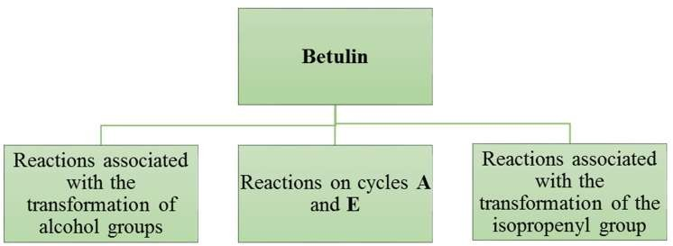
Scheme 1. The basic approaches to the chemical transformation of betulin (1).
The most common method of chemical transformation of betulin (1) is a variety of reactions by alcohol groups (Scheme 2).
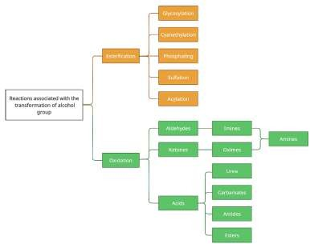
Scheme 2. The reactions of alcohol groups of betulin (1).
As can be seen from Scheme 2, the transformation processes of alcohol groups at the initial stage are aimed at esterification and oxidation reactions, which open the way to further functionalization with the formation of a wide variety of compounds.

The reactions of betulin in cycles A and E are mainly represented by transformations of lateral cyclohexane and cyclopentane rings through the processes of oxidation, halo-genation, alkylation, condensation and intramolecular rearrangement (Scheme 3).
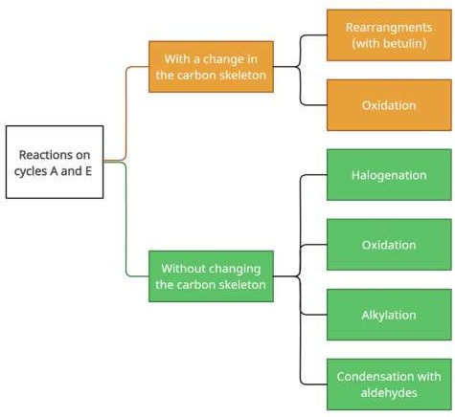
Scheme 3. The reactions of betulin (1) in cycles A and E.
The methods of chemical modification for the isopropenyl group of betulin are de-termined by the processes occurring with the participation of the olefin fragment and the functionalization of the terminal methyl group (Scheme 4). One of the interesting and promising pathways of the functionalization of the isopropenyl group is the path to the creation of azacycles through the processes of aminolysis of intermediates.
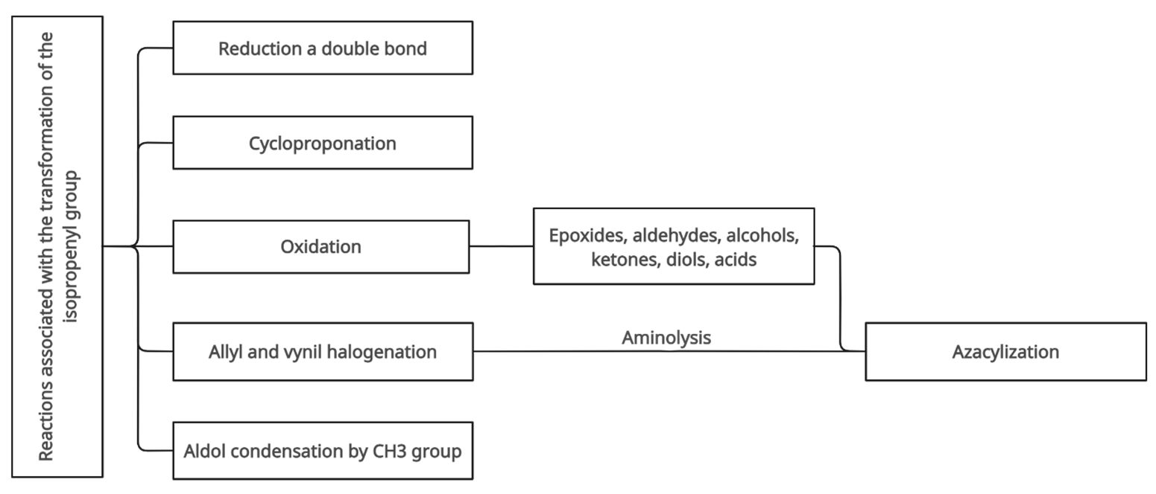
Scheme 4. The reactions of betulin (1) associated with the transformation of the isopropenyl group.
Many studies have been devoted to the methods of chemical modification of betulin derivatives with biological activity, including in reviews [8,80–83]. Research on the tar-geted synthesis of betulin and betulinic acid derivatives with improved solubility began in 2000–2012, including the Gzuka review of patents [84].
Thus, summing up this part of the review, it should be noted that:
- Betulin and its derivatives are important strategic objects for medicine and pharmacy as drugs of anti-HIV, antitumor, hepatoprotective, hypolipidemic and other types of action.
- A necessary part of the research of betulin and its derivatives as potential medicinal substances is the study of polymorphism and the existence of structural modifications with various biopharmaceutical characteristics.

- A special place among the methods for obtaining betulin derivatives is occupied by modification methods to give hydrophilicity and, accordingly, better solubility and bioavailability, which in turn makes it possible to prepare hydrophilic dosage forms, including injection type.

Methods of Analysis of Betulin and Its Structural Analogues
As is known, plant species from different geographical locations can show a variable composition of total isolation products, which is also observed when extracting triterpenes from birch bark. The identification of birch bark in close connection with the geographical location is crucial to ensuring the quality and effectiveness of the raw material before it is converted into the target product. Considering that traditional approaches in analyti-cal chemistry do not allow the rapid and reliable analysis of extractive substances, natural product manufacturers are constantly in search of faster and cheaper methods for check-ing their qualitative and quantitative composition, but most developed methods for the purification of betulin and its derivatives cannot achieve the criteria for the purity of the drug. Especially high purity requirements for betulin and its derivatives are imposed for dietary supplements, biochemical tests and medical practices.
  - Identification of Birch Bark Species
A chemical indicator is used to identify the outer bark of fluffy and silver birch [85]. Thus, the diarylheptanoid glycoside platyphylloside, present in high concentrations in the inner bark of silver birch (20–30 mg/g) and in low concentrations in the inner bark of fluffy birch (<0.5 mg/g), makes it possible to distinguish these species using an indicator due to the rapid formation of orange sediment with platyphylloside.
  - Determination of Monosaccharides in Extracts for Pretreatment
Monosaccharides (in terms of hexoses) in birch bark extracts after pretreatment with hot water or an alkaline solution were determined by the Malaprade reaction. The 1,2-diols and 1,2,3-triols were oxidized by potassium periodate according to the method described in [86].
  - IR and Raman Spectroscopy
IR spectroscopy is the most effective and non-destructive analytical approach for the reliable identification of triterpenes obtained by various extraction methods, among the many instrumental methods of analysis [87–90]. For example, the ratio of the absorption band intensities at 1633 cm⁻¹ is proposed to be used as a reference for comparing the content of triterpenes in birch bark [28,87,91,92]. Thus, ATR-FT-IR spectra of three birch bark extraction products (Romania) [89] were compared with those reported for isolated terpene compounds from Betula utilis and Hyptis suaveolens from the Himalayas [88] or Betulaceae cortex and Betula pendula Roth. [88] native to Central Europe. An analysis of IR spectra (KBr tablets) of Betulaceae extracts isolated by column chromatography in [88] led to the conclusion that triterpene substances, namely betulin, betulinic acid and lupeol obtained from birch bark (Betula pendula Roth.), give identical characteristic signals and optical density. However, comparison of the IR data of reference samples does not allow for distinguishing between betulin and lupeol. A detailed study conducted in another work [89] led to the conclusion that actual betulin demonstrates absorption bands in the ranges of 3430, 1716, 1641, 1600, 1581, 1291 and 881 cm⁻¹, whereas betulinic acid has them
at 3508, 1710, 1690, 1641, 1600, 1580 and 1290 cm⁻¹, despite their high structural similarity.
In [93], vibrational FT-IR and FT-Raman spectroscopy were used as a fast, sensitive and effective method for the qualitative and semi-quantitative analysis of pentacyclic nat-ural products of terpene nature obtained from the bark of Betula pendula Roth. growing in the Apuseni Mountains (Romania). A GC-MS analysis of extracts revealed two main compounds: betulin (59%) and lupeol (41%). The main IR/Raman spectra are presented for the isolated terpenes. The spectral imprint associated with pure triterpenes, where be-

tulin bands predominated. It was found that betulinic acid is less noticeable as a separate compound during isolation, on the one hand because of its low concentration and, on the other hand, because of the weak Raman intensity characteristic for the –COOH group at 1681 and 1718 cm⁻¹. Based on the analysis of IR and Raman spectra, the authors concluded that all extracts, regardless of the solvents used, revealed the dominant content of betulin and then lupeol. The work shows that Raman spectroscopy can provide semi-quantitative information regarding the content of triterpene in the final product by analyzing the ra-tio of the relative intensity of the 1642 cm⁻¹ range (mode C=C) and 1601 cm⁻¹, relative to other residual organic compounds from the bark. Since Raman measurements can also be performed on fresh plant material, this paper demonstrates the possibility of applying the results obtained to predict the highest triterpene content in tree bark for optimal col-lection time or for selecting individual genotypes directly in the field with the appropriate portable Raman equipment.
  - Chromatographic and Other Methods
The gas chromatographic separation of betulin-containing analytes is performed at elevated temperatures (above 300 ◦C) or after preliminary derivatization due to their low volatility [94], which makes the analysis long. Liquid chromatography by reverse-phase HPLC with spectrophotometric detection has found the widest application among the op-tions for performing chromatographic analyses of betulin and its derivatives [48,95,96]. The absence of chromaphore groups that intensively absorb near-UV spectral regions in triterpenoid molecules determines their detection at wavelengths of 205–210 nm. Gradient elution worsens the reproducibility and reliability of the results of their analysis. In addi-tion, this method is characterized by low sensitivity: the content limits are at the level of 0.1–1 mg/L.
The determination of betulin and betulinic acid in birch bark using RP-HPLC [48] ex-traction was tested using various solvents. The authors concluded that 95% ethanol in wa-ter is a good extraction solvent that allows the extraction of the high content of triterpenes. Separation was achieved in the reverse phase of the C18 column with acetonitrile/water 86:14 (vol./vol.). The detection was carried out using UV detection at λ = 210 nm. It was found that the content of triterpenes on the example of betulin and betulinic acid in the bark of white birch varies significantly depending on the place of growth in China [48].
High-performance liquid chromatography with reverse-phase (RP-HPLC) [9,15,48,97–101] and gas chromatography with mass spectrometric detection (GC-MS) [102,103] are widely used methods for analyzing samples of betulin and other triterpenes. Reverse-phase high-performance liquid chromatography (RP-HPLC) was used for the si-multaneous extraction and determination of betulin and betulinic acid from white birch bark [48]. Betulin was isolated from the extract of dried carpophore Xanthoceras sorbifolia Bunge by chromatographic methods and identified based on spectral data [48].
Nevertheless, thin-layer chromatography (TLC, especially in the high-performance modification—HPTLC) is also well applicable for assessing purity and visualizing impuri-ties [88,104,105].
In [106], one of the fractions of betulin extract was crystallized from an ethanol solu-tion in the form of flat transparent colorless small crystals with an average size of about
0.2 mm in length. Much larger crystals of up to 12 mm long are formed if a hot saturated ethanol solution is slowly cooled to room temperature. Betulin crystallizes from an ethanol solution with orthorhombic symmetry with one ethanol molecule per one hydrogen-bonded betulin molecule [14,51,107]. One of the classical physico-chemical char-acteristics of pure substances is their melting point. In the literature, there is a wide range of melting temperatures attributed to betulin 251–261 ◦C [51]. Most authors are inclined to a value of about 255 ◦C. Thus, when the betulin sample was heated, the following crys-tal changes were observed: 130–140 ◦C—darkening of crystals due to ethanol evaporation; 160–170 ◦C—betulin began to sublimate noticeably; 180–200 ◦C—new transparent micro-crystals appeared on the surface of the initial crystals; 255–256 ◦C—total melting. Crystals

did not form after cooling, and the melt solidified in the amorphous glassy form. Amor-phous microscopic beads were also formed in the form of a bright white powder during sublimation at atmospheric pressure in a sublimator [106].
Birch bark consists of ~75% brown inner bark and ~25% white outer bark. The outer bark contains fats, fatty acids, resins, suberin and especially betulin—up to 30% [6]. In [106], a simple approach was used to microscopically determine the location of triterpenes in birch bark. The authors made a lateral section of the bark to which Nile red dissolved in dimethyl phthalate was added. Fluorescence microscopy was used to obtain the image. Nile red fluorescent dye is very lipophilic, and, therefore, is used for labeling lipophilic structures. Thus, this method allows the identification of brighter areas in the photo that indicate the location of hydrophobic triterpenes. Betulin is especially clearly determined when using fluorescence microscopy. The structure of the birch bark, revealed after mark-ing with Nile red, allowed us to establish that betulin is localized by small longitudinal shells passing through the birch bark. Taking into account the presence of triterpene shells and the heterogeneity of the localization of betulin particles, the authors point out the need to pay due attention to the mechanical processing of birch bark before the extraction pro-cess. This observation is confirmed by the fact that the bark cut into small pieces (about 5 × 5 mm) gave, on average, only about 19% of extractives, whereas grinding to 4 µm gave more than 45% of extractives.
The structures of betulin and its derivatives as well as the qualitative and quantita-tive compositions of dry and liquid extracts were established using a complex of physico-chemical analysis methods: TLC, IR spectroscopy, ¹H and ¹³C NMR spectroscopy and chromatography-mass spectrometry. Thus, the identification of the betulin conversion product—betulin diacetate—was carried out by NMR spectroscopy in [108]. The authors of [109] studied the composition of birch bark extract, while the quantitative content of betulin was determined using the chromatography-mass spectrometry method.
An obvious alternative to the spectrophotometric detection of triterpenoids in liquid is mass spectrometry, which is characterized by high sensitivity, extremely high selectivity and a wide dynamic range. The use of HPLC mass spectrometry for the determination of lupane, oleanane and ursan and their comparison with other methods is shown in [110], and it is established that the best results can be obtained by chemical ionization at atmo-spheric pressure (APCI) and photochemical ionization at atmospheric pressure (APPI) us-ing toluene as a dopant. The achieved detection limits for various compounds were in the range of 5–15 mcg/L and 2–840 mcg/L for APCI and APPI, respectively. It was shown that in the case of chemical ionization, high sensitivity was achieved for betulinic acids, and for other triterpenoids, the detection limits were at the level of hundreds of mcg/L. The method of increasing the sensitivity and reliability of the determination of triterpenoids, especially in the analysis of complex matrices using tandem mass spectrometry, was suc-cessfully used in [111] for blood plasma analysis in the study of the pharmacokinetics of betulonic acid with a detection limit of 3 mcg/L.
The ion-induced dissociation (IID) spectra of betulonic acid derivatives along with the spectra of other triterpenoids containing carboxyl groups were studied in [112] for the reliable identification of analytes. A wider range of triterpenoids was investigated in [113]. The similarity of the spectra of compounds carrying saturated cycles with the spectra of electron ionization with a predominance of ring rupture was demonstrated [113]. It has been observed that triterpenoids with an unsaturated skeleton (olean and ursan) undergo fragmentation by a more complex mechanism due to the possibility of double bond mi-gration. In the development of these works [114], the HPLC MS/MS method of identifying and determining the four main components of birch bark extracts (betulin, lupeol, betulinic acid and erythrodiol) was developed (Figure 7).

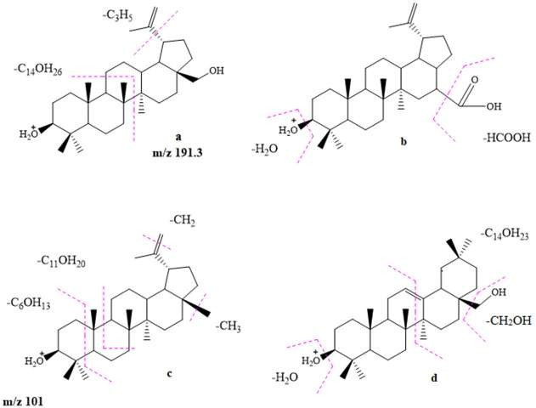
Figure 7. The structural formulas and possible ways of fragmentation of the studied compounds in the ion source: (a)—betulin, (b)—betulinic acid, (c)—lupeol, (d)—erythrodiol.
The developed method of the highly sensitive and selective determination of betulin, lupeol, erythrodiol and betulinic acid is proposed based on a combination of chromato-graphic separation with tandem detection of mass spectrometry. It was found that the APCI/MS/MS method is preferable and provides detection limits of the studied compounds at the level of several parts per billion and is characterized by a linear dynamic range span-ning more than three orders of magnitude.
It has been shown that the insufficient purity of substances isolated from extracts or reaction mass containing target substances is a serious hindrance for voltametric stud-ies [115] during the determination of antioxidant activity as well as the further chemical modifications of triterpenes. Obviously, such studies dictate the need for simple ways to clean them from accompanying impurities. Therefore, one of the urgent tasks is to de-velop simple and effective ways to purify substances containing triterpenes. We have al-ready noted above that currently, the literature information on the methods of purifying triterpenes is presented, as a rule, by methods of recrystallizing betulin and its derivatives from various solvents (such as lower aliphatic alcohols, chloroform, acetone, ethyl acetate, dichloromethane, etc.). However, these techniques are associated with the formation of solvate complexes with triterpenoids, which makes it difficult to identify them as individ-ual compounds [62]. In addition, significant losses (up to 40%) of the target substances are observed when using ethanol as a solvent for recrystallization [62]. To overcome such hindrances, the methods of purification of representatives of the lupane and oleane series using recrystallization and column chromatography methods were considered in [116], and the effectiveness of these methods was compared. The best result was achieved when dry extracts were purified by column chromatography with aluminum oxide as a sorbent and acetone as an eluent. In this case, according to chromato-mass spectrometric analysis, an increase in the content of the main substance in the sample by 4–7% to 95–98% levels was recorded.
It was shown that this method is convenient for the purification of betulin, betulin diacetate and allobetulin from concomitant impurities and allows us to obtain their pure substances suitable for further use in organic synthesis, electrochemical, microbiological and other research methods. The advantages of the proposed chromatographic method of purification of triterpenoids are the simplicity of execution, expressiveness and high purity of the obtained samples.

A systematic spectral and chromatographic study was carried out for the isolated pen-tacyclic triterpenoids (betulin (1), betulin diacetate (9) and allobetulin (8)) using a number of physico-chemical analysis methods (IR, PMR, GCMS) in [117]. The conditions were se-lected to ensure the suitability of TLC analysis for the qualitative detection of the listed compounds, and conditions of HPLC analysis for qualitative and quantitative determina-tion of betulin were found and described.
The authors systematized the obtained spectral (IR, NMR, GCMS) and chromatographic (TLC, HPLC) data on the physicochemical properties of the most important representatives of the lupane and oleane series—betulin (1), betulin diacetate (9) and allobetulin (8), the struc-tures of which are shown in Figure 8.

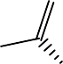





Figure 8. The structural formulas of betulin (1), betulin (9) diacetate and allobetulin (8).
  - The Analysis of 3β,28-Dihydroxy-20(29)-lupen (1), Betulin (1)
In the IR spectrum of betulin (1), there is a wide absorption band at 3359 cm⁻¹ belong-ing to valence vibrations of hydroxyl groups (Table 1). The stretching modes of the =CH₂ group are observed at 3078 cm⁻¹; the ones of the C–H groups are observed as a series of bands at 2944 and 2870 cm^{–1}. The bending vibrations of a multiple C=C bond are detected at 1695 and 1644 cm⁻¹. The vibrations of the CH₂ groups are attributed to 1457 cm⁻¹, and those of the CH₃ group are attributed to the band at 1374 cm⁻¹. The stretching mode of the C–O group is observed as a strong band at 1029 cm⁻¹.
In the ¹H NMR spectrum of betulin (1), there are two singlet signals in the region of
4.58 and 4.68 ppm, referring to the chemical shift of =CH₂ multiple bond protons (Table 1). Also, the spectrum is characterized by the presence of two doublet signals at
3.32 and 3.79 ppm, referring to protons at the 28th position. The proton in the 3-position is marked by the presence of a quadrupled signal at 3.18 ppm. The complex signal corre-sponded to a proton at the 19th carbon atom appearing at 2.38 ppm. There is an ensemble of signals of the CH₃, CH₂ and CH groups in the region of 0.65–2.15 ppm.
In the mass spectrum of betulin (1), there were peaks of high fragment intensities of 203, 189, 135, 121, and 95 (M⁺), characteristic of the lupan skeleton along with a small peak of the molecular ion 442 (M⁺) (Table 1).
  - The Analysis of 3β,28-Diacetoxy-lup-20(29)-en(9), Betulin Diacetate (9)
The stretching modes of =CH₂ groups were located at 3066 cm⁻¹, and the modes of alkyl fragments of C–H groups were observed as a series of bands at 2945 and 2869 cm⁻¹ in the IR spectrum of betulin diacetate 2 (Table 1). The vibrations of the carbonyl C=O group were detected as a strong absorption band at 1733 cm⁻¹. The bending vibrations of the CH₂ and CH₃ groups were attributed to 1457 cm⁻¹ 1367 cm^{–1}, respectively. The strong band at 1241 cm⁻¹ corresponded to the stretching mode of the C–O group.
In the ¹H NMR spectrum of betulin diacetate (2), there were two singlet signals in the region of 4.58 and 4.68 ppm, referring to the chemical shift of =CH₂ multiple bond protons (Table 1). There was a quadruplet signal at 4.46 ppm, corresponding to a proton in the

3-position. Two doublet signals at 3.84 and 4.24 ppm were assigned to proton bonds at the 28-position. The signal at 2.43 ppm referred to a proton at the 19 carbon atom. There was a complex of signals of the CH₃, CH₂ and CH groups in the region of 0.74–2.15 ppm.
Table 1. Spectral characteristics and Tmp of betulin (1), betulin diacetate (9) and allobetulin (8).

Compound Spectral Characteristics Tm.p., ◦ C IR Spectrum (KBr, υ, cm−1 ) ¹H NMR Spectrum (CDCl₃, δ, ppm., J/Hz) Mass Spectrum, m/z (I_{rel.,} %)

442 (M⁺, 6),
411 (16),

3359 (OH), 3078, 2944, 2870
1 (CH), 1695, 1644, 1457, 1457,
1374, 1029, 884, 759

3066 (=CH₂), 2945,
2869 (C–H), 1733 (C=O), 1457,
1367,
9 1241,
1018, 979,
889

3430 (O–H), 2939, 2867(C–H),
1450,
1386,
1375,
1361,
1301,
1264,
1206,
8 1138, 1076,
1041,
1008,
988,
973,
946,
929,
888,
813,
769
0.65–2.15 (complex, CH₃, CH₂, CH),
2.38 (1H, dt, H-19, J = 11.5 и 6.3),
3.18 (1H, dd, H-3, J = 11.2 и 5.4),
3.32 и 3.79 (2H, 2d, H-28, J = 10.8), 4.58 и 4.68 (2H, s, H-29)

0.74–2.15 (complex, CH₃, CH₂, CH),
2.43 (1H, dt, H-19, J = 10.8 и 5.7),
3.84 и 4.24 (2H, 2d, H-28, J = 11.1), 4.46 (1H, dd, H-3, J
= 9.3 и 3.6),
4.58 и 4.68 (2H, s, H-29)

0.65–1.82 (complex, CH₃, CH₂, CH),
3.19 (1H, m, H-3), 3.44 (1H, d, J = 6.5 и H-28),
3.52 (1H, s, H-19), 3.77 (1H, d, J = 6.5 и H-28)
363 (16),
203 (56),
189 (100),
135 (74),
121 (80),
95 (90),
69 (56), 55 (67)
526 (M⁺, 1),
466 (38),
423 (45),
363 (30),
227 (21),
203 (38),
189 (100),
161 (47),
135 (69),
121 (83),
91 (74),
67 (42),
55 (42)
442 (M⁺, 28),
424 (28),
411 (14),
371 (26),
355 (7),
220 (18),
207 (74),
189 (100),
177 (37),
148 (49),
134 (58),
121 (53),
107 (58),
95 (84),
81 (88),
69 (72),
55 (58)

258–260

215–219

262–265

In the mass spectrum of betulin diacetate (2), along with an insignificant peak in the intensity of the molecular ion 526 (M⁺), there were peaks of high intensity of fragments of 189, 135, 121 and 91, characteristic of the lupan backbone, as well as peaks of medium intensity of 466, 423, 203, 161, 67 and 55 (Table 1).
  - The Analysis of 3β-Hydroxy-19β,28-epoxy-18α-olean (8), Allobetulin
In the IR spectrum of allobetulin (3), there was a broadened absorption band at 3430 cm⁻¹ (Table 1) assigned to the stretching modes of the hydroxyl group. The stretch-ing modes of C–H groups were observed as a series of bands at 2939 and 2867 cm⁻¹. The bending vibrations of CH₂ and CH₃ groups were attributed to a band at 1450 cm⁻¹ and a series of bands in the regions of 1386, 1375 and 1361 cm⁻¹, respectively. The strong band at 1041 cm^{–1} corresponded to the stretching mode of the C–O group.
In the ¹H NMR spectrum of allobetulin (8), there were two doublet signals at 3.77 and
3.44 ppm, related to protons –CH₂ bonds at the 28-position of the carbon atom (Table 1). Also, in the spectrum, there was a singlet signal at 3.52 ppm corresponding to the proton of the CH group at the 19th position. The multiplet signal in the region of 3.19 ppm was assigned to the proton of the CH group at the 3rd carbon atom. There was an ensemble of signals of the CH₃, CH₂ and CH groups in the region of 0.65–1.82 ppm.

In the mass spectrum of allobetulin (8), along with the peak of the molecular ion 442 (M⁺), there were peaks of high fragment intensity of 207, 189, 134, 107, 95, 81, 69 and 55, characteristic of the olean backbone, and there were peaks of a medium intensity of 177, 148 and 121 (Table 1).
In the second stage of this work, the chromatographic characteristics (TLC, HPLC) of the dry substances of betulin (1), betulin diacetate (9) and allobetulin (8) were studied.
The most effective eluting systems (A–C: ethyl acetate: hexane = 1:1 (A), hexane: ethyl acetate = 4:1 (B), chloroform: ethanol = 40:1 (C) were selected to obtain correct TLC analysis data for the qualitative determination of compounds 1, 8 and 9. A sample of betulin (1) was chromatographed in system A; the Rf index was 0.40. A sample of betulin diacetate
(9) was chromatographed in system B (Rf 0.66), and a sample of allobetulin (8) in system C (Rf 0.37). The appearance of spots in all cases was carried out with a modified Ehrlich reagent since no spots are detected when the plates are UV irradiated with photons of a standard wavelength of 254 nm.
The betulin (1) samples were examined by HPLC. A sample of betulin (1) of a high de-gree of purification (with a content of 98% according to HGMS data) was used as a working standard (WS). The test samples of botulin and WS and the placebo samples were dissolved in acetonitrile with a concentration of 1 mg/mL. The samples were centrifuged for 10 min to remove the insoluble particles and placed in an autoclave and chromatographed using an Agilent 1260 Infinity liquid chromatograph with a diode-matrix detector. The column measuring 100 × 4.6 mm (inner diameter) was made of stainless steel and equipped with a pre-column. Zorbax Extend-C18 Rapid Resolution 3.5 microns 80 Å was used as the stationary phase. The mobile phase was a mixture of solvents: water—acetonitrile = 3:7. Isocratic elution was carried out. The temperature of the column was 40.0◦C. The volu-metric flow rate was 0.6 mL/min. The analysis time was 30 min. The temperature of the detector cell was 40.0 ◦C. The substances were detected using four wavelengths: 200 nm, 220 nm, 230 nm and 250 nm.
The selected conditions ensured the suitability of the technique for the qualitative and quantitative analysis of betulin (1). At the same time, the retention time for betulin (1) cor-responded to 17.2 min (Figure 9). The corrected retention time was 15.5 min. The retention factor was at least 9. The efficiency of the betulin column was at least 50,000 theoretical plates.
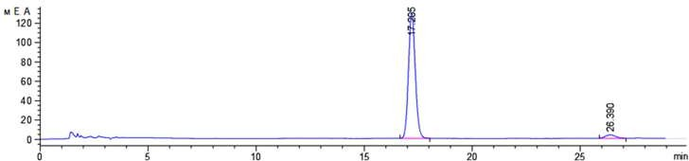
Figure 9. Chromatogram of betulin (1) sample (HPLC analysis).
The currently available methods [62] of purifying betulin are mainly based on its re-crystallization from polar protons and aprotic solvents. As a rule, the use of solvents for recrystallization, such as lower aliphatic alcohols, chloroform, acetone, ethyl acetate and dichloromethane, leads to the formation of solvate complexes with betulin. It should be noted that these solvents have low selectivity to concomitant impurities of betulin, such as lupeol, polyphenols and oxidized forms of betulin (betulin and betulonic acids and alde-hydes). In addition, the use of these solvents for recrystallization leads to significant losses of betulin, which can reach 40%.
The possibility of purifying betulin (1) using a high-boiling hydrocarbon solvent was investigated to achieve a higher degree of purity. Nonane, which has a boiling point of 151 ◦C, was taken as an example for research and repeatedly returning into the presence of betulin until it was completely dissolved [118,119]. It has been established that the use

of nonane as a solvent for recrystallization of betulin (1) makes it possible to obtain betulin with a purity of up to 98%.
It is important to note that the use of a high-boiling hydrocarbon solvent, such as nonane, avoids the formation of stable betulin solvate complexes and ensures the selective isolation of compounds included in the total alcohol extract of birch bark due to differences in their physico-chemical properties
Thus, the proposed method makes it possible to effectively separate valuable prod-ucts (such as betulin), polyphenol fractions and phytosterols contained in extractive plant materials using a simpler and cheaper technological scheme. The proposed method makes it possible to obtain betulin with a purity of 98%, suitable for use in subsequent chemical transformations without additional purification. In addition, a fraction of substances that are valuable for further use and contain polyphenols and phytosterols was obtained as a by-product. During the development of betulin purification technology, it was shown that the used solvent (nonan) could be reused.
This article is a logical continuation of the work [120].

Conclusions
Summarizing the generalized material on the methods of analysis and identification of betulin and some of its related compounds, it can be concluded that the analytical control of their quality is crucial for obtaining targeted pentacyclic triterpenoids with specified properties, especially for testing biological activity in food supplements and cosmetics.
Since betulin oxidation products are precursors of many biologically active compounds—potential drugs—in our opinion, generalized physicochemical characteris-tics of these compounds will be extremely useful to researchers in this field. Below, we have summarized the literature data on IR and NMR spectroscopy in the table (see Appendix A) and given the melting temperatures of key acids and aldehydes based on betulin.
Author Contributions: A.T.T. and E.A.M. developed the concept of the work. A.A.B., M.V.L. and
O.V.D. wrote the review. G.K.Z., R.S.Y., R.Z.K. and M.K.I. was engaged in an applied type of scien-tific activity. All authors have read and agreed to the published version of the manuscript.
Funding: This research was funded by the Science Committee of the Ministry of Science and Higher Education of the Republic of Kazakhstan (Grant No. AP AP08856688-OT-22 Development of meth-ods for the extraction of natural triterpenoids from plants and their chemical transformation in order to investigate for new biologically active substances). This study was supported by the Tomsk State University Development Programme (Priority 2030).
Institutional Review Board Statement: Not applicable.
Informed Consent Statement: Not applicable.
Data Availability Statement: Not applicable.
Conflicts of Interest: The authors declare no conflict of interest.
Sample Availability: Not applicable.

Appendix A Oxo Derivatives of Botulin








Betulinic acid
Betulinaldehyde
Betulonic acid
Betulonic aldehyde

IR, cm⁻¹ 1H-NMR, ppm 13C-NMR, ppm HPLC-MS m/z (%) Melting Temperature
4.68 s (1H, 29-H),

Betulonic acid

Betulinic acid

Betulonic aldehyde

Betulinaldehyde

1705 st (C=O)
1641 st (C=C)
883 st (=CH₂)

3450 st (OH),
1683 st (C=O),
1641 st (C=C);
883 st (=CH₂);
1031, 1042 st (α,
β-3-C–OH).

1730–1728 st (C=O),
1641 st (C=C);
883 st (=CH₂)
4.55 s (1H, 29-H),
2.23 m (1H, 19-H),
1.65 s (3H, 30-CH₃),
1.02–1.95 (3H, complex, CH₂, CH),
1.02 s (3H, 26-CH₃),
1.00 s (3H, 25-CH₃),
0.98 s (3H, 27-CH₃),
0.86 s (3H, 23-CH₃),
0.85 s (3H, 24-CH₃)
4.68 s (1H, 29-H),
4.55 s (1H, 29-H),
3.24 t (1 H, 3β-H),
2.99 dd (1H, 3α-H),
2.23 m (1H, 19-H),
1.65 s (3H, 30-CH₃),
1.02–1.95 (3H, complex, CH₂, CH),
1.02 s (3H, 26-CH₃),
1.00 s (3H, 25-CH₃),
0.98 s (3H, 27-CH₃),
0.86 s (3H, 23-CH₃),
0.85 s (3H, 24-CH₃)
9.67 s (1H, 28-CHO),
4.68 s (1H, 29-H),
4.55 s (1H, 29-H),
2.99 dd (1H, 3α-H),
2.23 m (1H, 19-H),
1.65 s (3H, 30-CH₃),
1.02–1.95 (3H, complex, CH₂, CH),
1.02 s (3H, 26-CH₃),
1.00 s (3H, 25-CH₃),
0.98 s (3H, 27-CH₃),
0.86 s (3H, c, 23-CH₃),
0.85 s (3H, c, 24-CH₃)
0.75, (3H, c, 24-CH₃)
0.82, (3H, c, 23-CH₃),
0.95, (3H, 27-CH₃),
0.97, (3H, 25-CH₃),
1.03 (3H, 26-CH₃),
1.70 (3H, 30-CH₃),
4.81 (1H, 29-H),
4.61 (1H, 29-H),
3.4 dd(1H, 3α-H),
9.71 (1H, 28-CHO),

216.52 (C-3),
109.67 (C-29)
150.33 (C-20),
177.26 (C-28).

76.83 (C-3),
109.67 (C-29),
150.33 (C-20),
177.26 (C-28)

206.55 (C-28).

149.6 (C-20),
110.1 (C-29),
79.0 (C-3)
206.5 (C-28)
454 (M⁺,58),
248 (64),
19 (42),
205 (76),
189 (88),
136 (100),
121 (90).

457 (M⁺, 7)
307 (25),
154 (100),
136 (60).

133 (35.6),
 | 438 (11.5), [M-CHO]⁺
 | 409 (20.0), 273 (3.2),
 | 219 (20.2),
216.52 (C-3), 109.67 | 205 (38.4),
(C-29), 150.33 (C-20), | 189 (39.6), | 165–166 ◦C

105 (55.8),
81 (65),
55 (100).

245–248 ◦C

290–293 ◦C

192–193 ◦C

References
- Cichewicz, R.H.; Kouzi, S.A. Chemistry, biological activity, and chemotherapeutic potential of betulinic acid for the prevention and treatment of cancer and HIV infection. J. Med. Res. Rev. 2004, 24, 90–114. [CrossRef] [PubMed]
- Alakurtti, S.; Makela, T.; Koskimies, S.; Kauhaluoma, J. Pharmacological properties of the ubiquitous natural product botulin.
Eur. J. Pharm. Sci. 2006, 29, 1–13. [CrossRef]
- Şoica, C.M.; Dehelean, C.A.; Peev, C.; Aluas, M.; Zupko, I.; Kasa, P.; Alexa, E. Physico-chemical comparison study of betulinic acid, betulin and birch bark extract and in vitro investigation of their cytotoxic effects towards skin epidermoid carcinoma (A431), breast carcinoma (MCF7) and cervix adenocarcinoma (HeLa) cell-lines. Nat. Prod. Res. 2012, 26, 968–974. [CrossRef] [PubMed]
- Yogeeswari, P.; Sriram, D. Betulinic acid and its derivatives: A review on their biological properties. Curr. Med. Chem. 2005, 12, 657–666. [CrossRef] [PubMed]
- Melnikova, N.; Burlova, I.; Kiseleva, T.; Klabukova, I.; Gulenova, M.; Kislitsin, A.; Tanaseichuk, B. A practical synthesis of betulonic acid using selective oxidation of betulin on aluminium solid support. Molecules 2012, 17, 11849–11863. [CrossRef] [PubMed]
- Alakurtti, S. Synthesis of Betulin Derivatives against Intracellular Pathogens. Ph.D. Thesis, University of Helsinki, Helsinki, Finland, 6 September 2013.
- Tolstikov, G.A.; Flekhter, O.B.; Shuld, E.E.; Baltina, L.A.; Tolstikov, A.G. Betulin and Its Derivatives. Chemistry and Biological Activity. Chem. Sustain. Dev. 2005, 13, 1–29.
- Boryczka, S.; Bebenek, E.; Wietrzyk, J.; Kempinska, K.; Jastrzebska, M.; Kusz, J.; Nowak, M. Synthesis, structure and cytotoxic activity of new acetylenic derivatives of botulin. Molecules 2013, 18, 4526–4543. [CrossRef]
- Dehelean, C.A.; Soica, C.; Ledeţi, I.; Aluaş, M.; Zupko, I.; Galuscan, A.; Munteanu, M. Study of the betulin enriched birch bark extracts effects on human carcinoma cells and ear inflammation. Chem. Cent. J. 2012, 6, 137. [CrossRef]
- Del Carmen Recio, M.; Giner, R.; Manes, S.; Rios, J. Structural requirements for the anti-inflammatory activity of natural triter-penoids. Planta Med. 1995, 61, 182–185. [CrossRef]

- Gong, Y.; Raj, K.M.; Luscombe, C.A.; Gadawski, I.; Tam, T.; Chu, J.; Gibson, D.; Carlson, R.; Sacks, S.L. The synergistic effects of botulin with acyclovir against herpes simplex viruses. Antivir. Res. 2004, 64, 127–130. [CrossRef]
- Miura, N.; Matsumoto, Y.; Miyairi, S.; Nishiyama, S.; Naganuma, A. Protective effects of triterpene compounds against the cytotoxicity of cadmium in HepG2 cells. Mol. Pharmacol. 1999, 56, 1324–1328. [CrossRef]
- Szuster-Ciesielska, A.; Kandefer-Szerszen, M. Protective effects of betulin and betulinic acid against ethanol-induced cytotoxicity in HepG2 cells. Pharmacol. Rep. 2005, 57, 588–595. [PubMed]
- Kuznetsova, S.A.; Skvortsova, G.P.; Maliar, I.N.; Skurydina, E.S.; Veselova, O. Extraction of botulin from birch bark and study of its physico-chemical and pharmacological properties. Russ. J. Bioorg. Chem. 2014, 40, 742–747. [CrossRef]
- Drag, M.; Surowiak, P.; Drag-Zalesinska, M.; Dietel, M.; Lage, H.; Oleksyszyn, J. Comparision of the cytotoxic effects of birch bark extract, betulin and betulinic acid towards human gastric carcinoma and pancreatic carcinoma drug-sensitive and drug-resistant cell lines. Molecules 2009, 14, 1639–1651. [CrossRef] [PubMed]
- Şoica, C. Betulin—A Future Key-Player in the Treatment of Neoplasic Diseases. Med. Aromat. Plants. 2012, 1, e135. [CrossRef]
- Krol, S.K.; Kiełbus, M.; Rivero-Muller, A.; Stepulak, A. Comprehensive review on betulin as a potent anticancer agent. BioMed. Res. Int. 2015, 1, 1–11. [CrossRef] [PubMed]
- Krasutsky, P.A. Birch bark research and development. Nat. Prod. Rep. 2006, 23, 919–942. [CrossRef]
- Tang, J.-J.; Li, J.-G.; Qi, W.; Qiu, W.-W.; Li, P.-S.; Li, B.-L.; Song, B.-L. Inhibition of SREBP by a small molecule, betulin, improves hyperlipidemia and insulin resistance and reduces atherosclerotic plaques. Cell Metab. 2011, 13, 44–56. [CrossRef]
- Cunha, A.B.; Batista, R.; Castro, M.A.; David, J.M. Chemical stratigies towards the synthesis of betulinic acid and its more potent antiprotozoal analogues. Molecules 2021, 26, 1081. [CrossRef]
- Khwaza, V.; Mlala, S.; Oyedeji, O.O.; Aderibigbe, B.A. Pentacyclic Triterpenoids with Nitrogen-Containing Heterocyclic Moiety, Privileged Hybrids in Anticancer Drug Discovery. Molecules 2021, 26, 2401. [CrossRef]
- Amiri, S.; Dastghaib, S.; Ahmadi, M.; Mehrbod, P.; Khadem, F.; Behrooj, H.; Aghanoori, M.-R.; Machaj, F.; Ghamsari, M.; Rosik, J.; et al. Betulin and its derivatives as novel compounds with different pharmacological effects. Biotechnol. Adv. 2020, 38, 107409. [CrossRef] [PubMed]
- Al-Snafi, A.E. The medical importance of Betula alba—An overwiev. J. Pharm. Biol. 2015, 5, 99–103.
- Hordyjewska, A.; Ostapiuk, A.; Horecka, A.; Kurzepa, J. Betulin and betulinic acid: Triterpenoids derivatives with a powerful biological potential. Phytochem. Rev. 2019, 18, 929–951. [CrossRef]
- Berger, S.; Sicker, D. Classics in Spectroscopy: Isolation and Structure Elucidation of Natural Products, 1st ed.; Wiley-VCH Verlag: Weinheim, Germany, 2009; ISBN 978-3-527-32516-0.
- Gilberg, M.R. Plasticization and forming of misshapen birch-bark artifactsusing solvent vapours. Stud. Conserv. 1986, 31, 177–184.
- Hayek, E.W.H.; Jordis, U.; Moche, W.; Sauter, F. A bicentennial of botulin. Phytochemistry 1989, 28, 2229–2242. [CrossRef]
- Pinzaru, S.C.; Leopold, N.; Kiefer, W. Vibrational spectroscopy of betulinic acid HIV inhibitor and of its birch bark natural source.
Talanta 2002, 57, 625–631. [CrossRef]
- Jaaskelainen, P. Betulinol and its utilization. Paperi. Ja. Puu. 1981, 63, 599–603.
- Pohilolo, N.D.; Uvarova, N.I. Izoprenoidy razlichnyh vidov roda Betula. Him. Prir. Soedin. 1988, 3, 325–341.
- Tolstikov, G.A.; Flehter, O.B.; Shul’c, J.J.; Baltina, L.A.; Tolstikov, A.G. Betulin i ego proizvodnye. Himija i biologicheskaja aktivnost’. Him. V Interes. Ustojchivogo Razvit. 2005, 3, 1–30.
- Matjuhina, L.G.; Shmukler, B.C.; Rjabinin, A.A. Triterpenoidy kory Alnus subcordata S.A.M. Zhurn. Org. Him. 1965, 35, 579–580.
- Maurya, S.K.; Devi, S.; Pandey, V.B.; Khosa, R.I. Content of betulin and betulinic acid, antitumor agents of Ziziphus species.
Fitoterapia 1989, 60, 468–469.
- Kundu, A.B.; Barik, B.R.; Mondal, D.N.; Dey, A.K.; Baneryi, A. Ziziberanic acid a pentacyclic triterpenoid of Ziziphus jujuba. Phytochemistry 1989, 28, 3155–3158. [CrossRef]
- Melek, F.R.; Ranwan, A.S.; Achmedet, A.A.; Hamman, A.A.; Abualabi, E.A. Triterpenes from Atractylis carduus L. Pharmazie 1989,
44, 735.
- Siddiqui, S.; Siddiqui, B.S.; Naeed, A.; Begum, S. Pentacyclic triterpenoids from the leaves of Plumeria obtuse. Phytochemistry
1989, 28, 3143–3147. [CrossRef]
- Kulik, N.I.; Krasavskaja, N.P. Himicheskaja i Mediko-Biologicheskaja Ocenka Novyh Fitopreparatov, 1st ed.; Nauchno-proizvodstvennoe ob#edinenie: Moscow, Russia, 1989.
- Majumber, R.L.; Lahiri, S. Chemical constituents of the orchid Lusia indivisa. Indian J. Chem. B 1989, 28B, 771–774.
- Ma, Z.-Z.; Hano, Y.; Nomura, T.; Chen, Y.-J. Three New Triterpenoids from Peganum nigellastrum. J. Nat. Prod. 2000, 63, 390–392. [CrossRef] [PubMed]
- Nick, A.; Wright, A.D.; Rali, T.; Sticher, O. Antibacterial triterpenoids from Dillenia papuana and their structure-activity rela-tionships. Phytochemistry 1995, 40, 1691–1695. [CrossRef]
- De Majo, P. Terpeny, 1st ed.; Kucherov, V.F., Ed.; Inostrannaja Literature: Moskva, Rossija, 1963.
- Sharkov, V.I.; Beljaevskij, I.A. References. K voprosu o himicheskom sostave drevesnoj kory. Kora breezy. Lesohim. Promyshlen-nost 1932, 3, 30–33.
- Roshhin, V.I.; Shabanova, N.J.; Vedernikov, D.N. Sposob poluchenija betulina. Rossijskaja Federacija. Patent RU 2,184,120, 27 June 2002. Poccийcкaя Φeдepaция MΠK C07J53/00, C07J63/00.

- Kislicyn, A.N. Jekstraktivnye veshhestva beresty: Vydelenie, sostav, svojstva, primenenie. Him. Drev. 1994, 3, 3–28.
- Simonsen, J.L.; Ross, W.S. The Terpenes. Vol. 4: The Triterpenes and Their Derivatives: Hydrocarbons, Alcohols, Hydroxy-Aldehydes, Ketones and Hydroxy-Ketones, 1st ed.; Cambridge University Press: Cambridge, UK, 1957.
- Nikol’skij, B.P. Spravochnik Himika. Tom 2: Osnovnye Svojstva Neorganicheskih i Organicheskih Soedinenij, 2nd ed.; Himija: Moskva, Rossija, 1964.
- Levdanskij, V.A.; Polezhaeva, N.I.; Es’kin, A.P.; Vink, V.A.; Kuznecov, B.N. Sposob poluchenija betulina. Rossijskaja Federacija. Patent RU 2,131,882, 29 March 1999.
- Zhao, G.; Yan, W.; Cao, D. Simultaneous determination of betulin and betulinic acid in white birch bark using RP-HPLC. J. Pharm. Biomed. Anal. 2007, 3, 959–962. [CrossRef]
- Reichardt, C. Solvents and Solvent Effects in Organic Chemistry, 2nd ed.; Wiley-VCH Verlag: Weinheim, Germany, 2003; ISBN 3-527-30618-8.
- Cao, D.; Zhao, G.; Yan, W. Solubilities of Betulin in Fourteen Organic Solvents at Different Temperatures. J. Chem. Eng. Data
2007, 52, 1366–1368. [CrossRef]
- Drebushchak, T.N.; Mikhailenko, M.A.; Brezgunova, M.E.; Shakhtshneider, T.P.; Kuznetsova, S.A. Crystal Structure Of Betulin Ethanol Solvate. J. Struct. Chem. 2010, 51, 798–801. [CrossRef]
- Odinokova, L.J.; Malinovskaja, G.V.; Pohilo, N.D.; Uvarova, N.I. Triterpenoidy kory i vetochek Betula davurica. Him. Prir. Soedin. 1985, 3, 414–415.
- Pohilo, N.D.; Mahnev, A.K.; Uvarova, N.I. Triterpenoidy list’ev i kory chernokoroj formy belyh berez Betula pendula i V. Pubescens. Him. Prir. Soedin. 1995, 6.
- Shon, L.B.; Kaplun, A.P.; Shpilevskij, A.A. Sintez betulinovoj kisloty iz betulina i issledovanie ee soljubilizacii s pomoshh’ju liposom. Bioorg. Him. 1998, 24, 787–793.
- Wang, X.; Gong, N.; Yang, S.; Du, G.; Lu, Y. Studies on Solvatomorphism of Betulinic Acid. J. Pharm. Sci. 2014, 103, 2696–2703. [CrossRef]
- Drebushchak, V.A.; Mikhailenko, M.A.; Shakhtshneider, T.P.; Kuznetsova, S.A. Melting of orthorhombic betulin. J. Therm. Anal. Calorim. 2013, 111, 2005–2008. [CrossRef]
- Cheng, Y.; Shao, Y.; Yan, W. Solubilities of Betulinic Acid in Thirteen Organic Solvents at Different Temperatures. J. Chem. Eng. Data 2011, 56, 4587–4591. [CrossRef]
- Boryczka, S.; Michalik, E.; Jastrzebska, M.; Kusz, J.; Zubko, M.; Bębenek, E. X-Ray Crystal Structure of Betulin–DMSO Solvate. J. Chem. Crystallogr. 2012, 42, 345–351. [CrossRef]
- Boryczka, S.; Jastrzebska, M.; Bębenek, E.; Kusz, J.; Zubko, M.; Kadela, M.; Michalik, E. X-Ray Diffraction and Infrared Spec-troscopy of N,N- Dimethylformamide and Dimethyl Sulfoxide Solvatomorphs of Betulonic Acid. J. Pharm. Sci. 2012, 101, 4458–4471. [CrossRef]
- Yang, D.; Gong, N.; Zhang, L.; Lu, Y. Isostructurality Among 5 Solvatomorphs of Betulin: X-Ray Structure and Characterization.
J. Pharm. Sci. 2016, 105, 1867–1873. [CrossRef]
- Tang, W.; Chen, N.-H.; Li, G.-Q.; Wang, G.-C.; Li, Y.-L. Crystal structure of betulinic acid methanol monosolvate. Acta Cryst.
2014, 70, 1242–1243. [CrossRef] [PubMed]
- Mihajlenko, M.A.; Shahtshnejder, T.P.; Brezgunova, M.E.; Drebushhak, V.A.; Kuznecova, S.A.; Boldyrev, V.V. Poluchenie i issle-dovanie fiziko-himicheskih svojstv sol’vatov betulina. Himija Rastitel’nogo Syr’ja 2010, 2, 63–70.
- Furtado, N.J.C.; Pirson, L.; Edelberg, H.M.; Miranda, L.; Loira-Pastoriza, C.; Preat, V.; Larondelle, Y.; Andre, C.M. Pentacyclic Triterpene Bioavailability: An Overview of In Vitro and In Vivo Studies. Molecules 2017, 22, 400. [CrossRef]
- Buckley, S.T.; Fischer, S.M.; Fricker, G.; Brandl, M. In vitro models to evaluate the permeability of poorly soluble drug entities: Challenges and perspectives. Eur. J. Pharm. Sci. 2012, 45, 235–250. [CrossRef]
- Benet, L.Z.; Hosey, C.M.; Ursu, O.; Oprea, T.I. BDDCS, the Rule of 5 and drugability. Adv. Drug Deliv. Rev. 2016, 101, 89–98. [CrossRef]
- Mullauer, F.B.; van Bloois, L.; Daalhuisen, J.B.; Ten Brink, M.S.; Storm, G.; Medema, J.P.; Schiffelers, R.M.; Kessler, J.H. Be-tulinic acid delivered in liposomes reduces growth of human lung and colon cancers in mice without causing systemic toxicity. Anticancer Drugs 2011, 22, 223–233. [CrossRef] [PubMed]
- Halder, A.; Shukla, D.; Das, S.; Roy, P.; Mukherjee, A.; Saha, B. Lactoferrin-modified Betulinic Acid-loaded PLGA nanoparticles are strong anti-leishmanials. Cytokine 2018, 110, 412–415. [CrossRef] [PubMed]
- Kaplun, A.B.; Meshalkin, A.B. Equation for the second virial coefficient of gases–High Temperatur. High Press. 1999, 31, 253–258. [CrossRef]
- Lomkova, E.A.; Chytil, P.; Janouškova, O.; Mueller, T.; Lucas, H.; Filippov, S.K.; Trhlíkova, O.; Aleshunin, P.A.; Skorik, Y.A.; Ulbrich, K.; et al. Biodegradable Micellar HPMA-Based Polymer–Drug Conjugates with Betulinic Acid for Passive Tumor Tar-geting. Biomacromolecules 2016, 17, 3493–3507. [CrossRef]
- Filippov, S.K.; Vishnevetskaya, N.S.; Niebuur, B.-J.; Koziolova, E.; Lomkova, E.A.; Chytil, P.; Etryc, T.; Papadakis, C.M. Influence of molar mass, dispersity, and type and location of hydrophobic side chain moieties on the critical micellar concentration and stability of amphiphilic HPMA-based polymer drug carriers. Colloid Polym. Sci. 2017, 295, 1313–1325. [CrossRef]
- Malyar, Y.; Kuznetsova, S.A.; Shakhtshneider, T.; Mikhailenko, M.A. Obtaining of Betulin Diacetate and Betulin Dipropionate Composites with Aerosil. J. Sib. Fed. Univ. Chem. 2015, 2, 277–286. [CrossRef]

- Dai, L.; Li, D.; Cheng, J.; Liu, J.; Deng, L.-H.; Wang, L.-Y.; Lei, J.-D.; He, J. Water soluble multiarm-polyethylene glycol–betulinic acid prodrugs: Design, synthesis, and in vivo effectiveness. Polym. Chem. 2014, 5, 5775–5783. [CrossRef]
- Sursyakova, V.V.; Levdanskya, V.A.; Rubayloa, A.I. Determining Stability Constants of Complexes Between Ester Betulin Deriva-tives and β-Cyclodextrin by Affinity Capillary Electrophoresis. J. Sib. Fed. Univ. Chem. 2020, 13, 534–541. [CrossRef]
- Mikhailenko, M.A.; Shakhtshneider, T.P.; Eltsov, I.V.; Kozlov, A.S.; Kuznetsova, S.A.; Karacharov, A.A.; Boldyrev, V.V.
Supramolecular architecture of betulin diacetate complexes with arabinogalactan from Larix sibirica. Carbohydr. Polym. 2016, 138, 1–7. [CrossRef] [PubMed]
- Falamaş, A.; Pînzaru, S.C.; Chiş, V.; Dehelean, C. Spectroscopic investigations of newly formed betulin-cyclodextrin guest–host type complexes as potential anti skin cancer candidates. J. Mol. Struct. 2011, 993, 297–301. [CrossRef]
- Soica, C.; Dehelean, C.; Danciu, C.; Wang, H.M.; Wenz, G.; Ambrus, R.; Bojin, F.; Anghel, M. Betulin Complex in γ-Cyclodextrin Derivatives: Properties and Antineoplastic Activities in In Vitro and In Vivo Tumor Models. Int. J. Mol. Sci. 2012, 3, 14992–15011. [CrossRef]
- Wang, H.M.; Şoica, C.M.; Wenz, G. A Comparison Investigation on the Solubilization of Betulin and Betulinic Acid in Cyclodex-trin Derivatives. Nat. Prod. Commun. 2012, 7, 289–291. [CrossRef]
- Dehelean, C.; Soica, C.; Peev, C.; Sorina, C.A.; Feflea, S.A.; Kasa, P. A pharmaco-toxicological evaluation of betulinic acid mixed with hydroxipropilgamma cyclodextrin on in vitro and in vivo models. Farmacia 2009, 59, 51–59.
- Gorbunova, M.N.; Krajnova, G.F. Triterpensoderzhashhie polimernye konstrukcii: Sintez i biologicheskaja aktivnost’. Vestn. Permsk. Nauchnogo Cent. 2014, 2, 44–51.
- Abyshev, A.Z.; Abyshev, R.A.; Nguen, V.H.; Morozova, V.A. Proizvodnye betulinola kak perspektivnye anti-VICh agenty.
Medicinskij Akademicheskij Zhurnal 2013, 13, 15–31.
- Periasamy, G.; Teketelew, G.; Gebrelibanos, M.; Sintayehu, B.; Gebrehiwot, M.; Karim, A.; Geremedhin, G. Betulinic acid and its derivatives as anti-cancer agent: A review. Arch. Appl. Sci. Res. 2014, 6, 47–58.
- Jonnalagadda, S.C.; Suman, P.; Morgan, D.C.; Seay, J.N. Recent Developments on the Synthesis and Applications of Betulin and Betulinic Acid Derivatives as Therapeutic Agents. Stud. Nat. Prod. Chem. 2017, 53, 45–84. [CrossRef]
- Laev, S.S.; Salahutdinov, N.F. Preparativnaja Himija Terpenoidov, 1 Izdanie; Akademizdat: Novosibirsk, Russia, 2016; Chapter 3; ISBN 978-5-9907917-5-6.
- Csuk, R. Betulinic acid and its derivatives: A patent review (2008–2013). antitumor activity, betulinic acid, cancer, cytotoxicity.
Expert Opin. Ther. Pat. 2014, 24, 913–923. [CrossRef]
- Lundgren, L.N.; Pan, H.; Theander, O.; Eriksson, H.; Johansson, U.; Svenningsson, M. Development of a new chemical method for distinguishing between Betula pendula and Betula pubescens in Sweden. Can. J. For. Res. 1995, 25, 1097–1102. [CrossRef]
- Besada, A.; Gawargious, Y.A. Iodometric submicro determination of α-amino-alcohols by an amplification reaction. Talanta 1974, 21, 1247–1252. [CrossRef] [PubMed]
- Dehelean, C.A.; Cinta-Pinzaru, S.; Soica, C.; Peev, C.I. Characterization of birch tree leaves, buds and bark dry extracts with antitumor activity. J. Optoelectron. Adv. Mater. 2007, 9, 783–787.
- Kovac-Besovic, E.E.; Duric, K.; Kalodera, Z.; Sofic, E. Identification and Isolation of Pharmacologically Active Triterpenes in Betuale Cortex, Betula Pendula Roth., Betulaceae. Bosn. J. Basic Med. Sci. 2009, 9, 31–38. [CrossRef]
- Sharma, P.P.; Roy, R.K.; Anurag, B.; Gupta, D. Pentacyclic Triterpinoids from Betula utilis and Hyptis suaveolens. Int. J. Pharmtech. Res. 2010, 2, 1558–1562.
- Schulz, H. Rapid Analysis Of Medicinal And Aromatic Plants By Non- Destructive Vibrational Spectroscopy Methods. Acta Hor.
2005, 679, 181–187. [CrossRef]
- Falamaş, A.; Pinzaru, S.C.; Dehelean, C.A.; Peev, C.I.; Soica, C. Betulin and its natural resource as potential anticancer drug candidate seen by FT-Raman and FT-IR spectroscopy. J. Raman Spectrosc. 2011, 42, 97–107. [CrossRef]
- Schulz, H.; Baranska, M. Identification and quantification of valuable plant substances by IR and Raman spectroscopy. Vib. Spectrosc. 2007, 43, 13–25. [CrossRef]
- Cinta-Pinzaru, S.; Dehelean, C.A.; Soica, C.; Culea, M.; Borcan, F. Evaluation and differentiation of the Betulaceae birch bark species and their bioactive triterpene content using analytical FT-vibrational spectroscopy and GC-MS. Chem. Cent. J. 2012, 6, 67. [CrossRef] [PubMed]
- Galgon, T.; Hoke, D.; Drager, B. Identification and quantification of betulinic acid. Phytochem. Anal. 1999, 10, 187–190. [CrossRef]
- Taralkar, S.V.; Chattopadhyay, S. A HPLC Method for Determination of Ursolic Acid and Betulinic Acids from their Methanolic Extracts of Vitex Negundo Linn. J. Anal. Bioanal. Tech. 2012, 3, 2–6. [CrossRef]
- Beregovcova, N.G.; Sharypov, V.I.; Baryshnikov, S.V.; Kuznecov, B.N. Issledovanie processa jekstrakcii beresty berezy jetanolom i izopropanolom pri povyshennyh temperaturah. Khimija Rastit. Syr’ja 2012, 1, 71–75.
- Hu, Z.; Guo, N.; Wang, Z.; Liu, Y.; Wang, Y.; Ding, W.; Zhang, D.; Wang, Y.; Yan, X. Development and validation of an LC–ESI/MS/MS method with precolumn derivatization for the determination of betulin in rat plasma. J. Chromatogr. B 2013, 939, 38–44. [CrossRef]
- Holonec, L.; Ranga, F.; Crainic, D.; Truta, A.; Socaciu, C. Evaluation of Betulin and Betulinic Acid Content in Birch Bark from Different Forestry Areas of Western Carpathians. Notulae Botanicae Horti Agrobotanici 2012, 40, 99–105. [CrossRef]
- Co, M.; Koskela, P.; Eklund-Åkergren, P.; Srinivas, K.; King, J.W.; Sjoberg, P.J.R.; Turner, C. Pressurized liquid extraction of betulin and antioxidants from birch bark. Green Chem. 2009, 11, 668–674. [CrossRef]

- Maji, A.K.; Maity, N.; Banerji, P.; Banerjee, D. Validated RP-HPLC-UV method for the determination of betulin in Asteracantha longifolia. Phytomedicine 2013, 5, 131–135.
- Pfarr, K.; Danciu, C.; Dehelean, C.; Pfeilschifter, J.M.; Radeke, H.H. Betulin—A plant-derived cytostatic drug-enhances antitumor immune response. J. ImmunoTher. Cancer 2014, 2, 175. [CrossRef]
- Orsini, S.; Ribechini, E.; Modugno, F.; Klugl, J.; Di Pietro, G.; Colombini, M. Micromorphological and chemical elucidation of the degradation mechanisms of birch bark archaeological artefacts. Herit. Sci. 2015, 3, 2. [CrossRef]
- Regert, M.; Alexandre, V.; Thomas, N.; Lattuati-Derieux, A. Molecular characterisation of birch bark tar by headspace solid-phase microextraction gas chromatography–mass spectrometry: A new way for identifying archaeological glues. J. Chromatogr. A 2006, 1101, 245–253. [CrossRef] [PubMed]
- Joshi, H.; Saxena, G.K.; Singh, V.; Arya, E. Phytochemical Investigation, Isolation and Characterization of Betulin from Bark of Betula Utilis. J. Pharmacogn. Phytochem. 2013, 2, 145–151.
- Tijjani, A.; Ndukwe, I.; Ayo, R. Isolation and Characterization of Lup-20(29)-ene-3, 28- diol (Betulin) from the Stem-Bark of Adenium obesum (Apocynaceae). Trop. J. Pharm. Res. 2012, 11, 259–262. [CrossRef]
- Siman, P.; Filipova, A.; Ticha, A.; Niang, M.; Bezrouk, A.; Havelek, R. Effective Method of Purification of Betulin from Birch Bark: The Importance of Its Purity for Scientific and Medicinal Use. PLoS ONE 2016, 11, e0154933. [CrossRef]
- Bhat, K.M. Anatomy, Basic Density and Shrinkage of Birch Bark. IAWA Bull. 1982, 3, 207–211. [CrossRef]
- Kuznecova, S.A.; Vasil’eva, N.J.; Kalacheva, G.S.; Titova, N.M.; Red’kina, E.S.; Skvorcova, G.P. Poluchenie diacetata betulina iz beresty kory berezy i izuchenie ego antioksidantnoj aktivnost. Zhurnal Sib. Fed. Univ. 2008, 1, 151–165.
- Koptelova, E.N.; Kutakova, N.A.; Tret’jakov, S.I. Opredelenie sostava jetanol’nogo jekstrakta beresty. Izvestija Vuzov. Lesn. Zhurnal. 2011, 6, 107–111.
- Rhourri-Frih, B.; Chaimbault, P.; Claude, B.; Lamy, C.; Andre, P.; Lafosse, M. Analysis of pentacyclic triterpenes by LC-MS. A comparative study between APCI and APPI. J. Mass Spectrom. 2009, 44, 71–80. [CrossRef]
- Gu, J.; Ding, G.; Chen, N.; Zhang, Z. Development and Validation of a Sensitive LC–MS-MS Assay for the Quantification of Betulonic Acid in Rat Plasma. J. Chromatogr. Sci. 2013, 52, 195–200. [CrossRef] [PubMed]
- Chen, G.; Li, J.; Song, C.; Suo, Y.; You, J. A sensitive and efficient method for simultaneous trace detection and identification of triterpene acids and its application to pharmacokinetic study. Talanta 2012, 98, 101–111. [CrossRef]
- Van der Doelen, G.A.; van den Berg, K.J.; Boon, J.J.; Shibayama, N.; Rene de la Rie, E.; Genuit, W.J.L. Analysis of fresh triterpenoid resins and aged triterpenoid varnishes by high-performance liquid chromatography–atmospheric pressure chemical ionisation (tandem) mass spectrometry. J. Chromatogr. A 1998, 809, 21–37. [CrossRef]
- Kosyakov, D.S.; Ul’yanovskii, N.V.; Falev, D.I. Determination of triterpenoids from birch bark by liquid chromatography-tandem mass spectrometry. J. Anal. Chem. 2014, 69, 1264–1269. [CrossRef]
- Kalieva, S.S.; Slepchenko, G.B.; Akeneev, J.A.; Nurpejis, E.E.; Tashenov, A.K.; Mamaeva, E.A.; Bakibae, A.A. Vol’tamperometricheskoe opredelenie betulina v jekstraktah rastitel’nogo proishozhdenijav. Zavodskaja Laboratorija 2017, 83, 18–22.
- Kalieva, S.S.; Mamaeva, E.A.; Nurpejis, E.E.; Bakibaev, A.A.; Tashenov, A.K.; Zamanova, M.K.; Kec, T.S. Sposoby ochistki neko-toryh pentaciklicheskih triterpenoidov. Vestn. Karagand. Univ. Ser. Him. 2017, 2, 35–39.
- Kalieva, S.S.; Mamaeva, E.A.; Nurpejis, E.E.; Bakibaev, A.A.; Tashenov, A.K.; Zamanova, M.K.; Kurgachev, D.A.; Ponarin, N.V. Spektral’nye i hromatograficheskie harakteristiki betulina i nekotoryh ego proizvodnyh. Vestn. Evrazijsk. Nac. Univ. Im. L.N. Gumileva. Ser. Estestv. Teh. Nauk. 2017, 4, 235–240.
- Janovskij, V.A.; Andrienko, O.S.; Zhuk, V.V.; Bakibaev, A.A.; Sachkov, V.I. Sposob ochistki betulina. Rossijskaja Federacija. Patent RU 2,463,306, 12 October 2012.
- Zhuk, V.V.; Janovskij, V.A.; Janovskaja, E.A.; Bakibaev, A.A.; Andrienko, O.S.; Sharafeev, S.M.; Sachkov, V.I. Perekristallizacija jekstraktov betulina iz vysokokipjashhih uglevodorodnyh rastvoritelej. Him. Rastit. Syr’ja 2012, 2, 73–78.
- Demets, O.V.; Takibayeva, A.T.; Kassenov, R.Z.; Aliyeva, M.R. Methods of Betulin Extraction from Birch Bark. Molecules 2022,
27, 3621. [CrossRef] [PubMed]

Disclaimer/Publisher’s Note: The statements, opinions and data contained in all publications are solely those of the individual au-thor(s) and contributor(s) and not of MDPI and/or the editor(s). MDPI and/or the editor(s) disclaim responsibility for any injury to people or property resulting from any ideas, methods, instructions or products referred to in the content.

molecules

Article

Obtaining New Biocompatible Composite Materials with Antibacterial Properties Based on Diatomite and Biologically Active Compounds

Saule Kabieva 1, Gaziza Zhumanazarova 1,*, Rymgul Zhaslan 1, Gulistan Zhumabayeva 2, Arthur Ukhov 3, Dmitry Fedorishin 3, Alexander Gubankov 3, Farkhad Tarikhov 3, Ordabay Yerkhan 2, Kurzina Irina 3, Rakhmetulla Yerkassov 2 and Abdigali Bakibaev 3

1 Department of Chemical Technology and Ecology, Karaganda Industrial University, Temirtau 101400, Kazakhstan; kabieva.s@mail.ru (S.K.); rima93@list.ru (R.Z.)
2 Faculty of Natural Sciences, L.N. Gumilyov Eurasian National University, St. Satbaeva 2, Almaty District,
Astana 010000, Kazakhstan; gulistan2009@mail.ru (G.Z.); kipchak_xan@mail.ru (O.Y.); erkass@mail.ru (R.Y.)
3 Chemical Faculty, National Research Tomsk State University, Arkady Ivanov St. 49, Tomsk 634028, Russia; artyryxov1@gmail.com (A.U.); strix187@yandex.ru (D.F.); 4.4.gub4nk0v@gmail.com (A.G.); farkhad.tarikhov@nu.edu.kz (F.T.); kurzina99@mail.ru (K.I.); bakibaev@mail.ru (A.B.)
* Correspondence: gaziza.zhumanazarova@mail.ru or g.zhumanazarova@tttu.edu.kz

Citation: Kabieva, S.; Zhumanazarova, G.; Zhaslan, R.; Zhumabayeva, G.; Ukhov, A.; Fedorishin, D.; Gubankov, A.; Tarikhov, F.; Yerkhan, O.; Irina, K.; et al. Obtaining New Biocompatible
Abstract: This study aimed to create new composite materials based on diatomite—a non-organic porous compound—through its surface modification with bioactive organic compounds, both syn-thetic and natural. Chloramphenicol, tetrahydroxymethylglycoluril and betulin were used as modify-ing substances. Composite materials were obtained by covering the diatomite surface with bioactive substance compounds as a solution and material dispersion in it. The materials were characterized by IR spectroscopy, SEM and X-ray photoelectron spectroscopy. For the biocomposites, the hemolytic ef-fect, plasma proteins’ adsorption on the surface and the antibacterial activity of the obtained materials were studied. Results show that the obtained materials are promising for medicine and agriculture.

Keywords: diatomite; betulin; chloramphenicol; tetrahydroxymethylglycoluril; biocompatible materials; antibacterial activity

Composite Materials with
Antibacterial Properties Based on Diatomite and Biologically Active

Compounds. Molecules 2024, 29, 1608. https://doi.org/10.3390/ molecules29071608
Academic Editors: Giuseppe Cirillo and Lin Lin
Received: 16 February 2024
Revised: 24 March 2024
Accepted: 28 March 2024
Published: 3 April 2024
Copyright: © 2024 by the authors. Licensee MDPI, Basel, Switzerland. This article is an open access article distributed under the terms and conditions of the Creative Commons Attribution (CC BY) license (https:// creativecommons.org/licenses/by/ 4.0/).

Introduction
In the modern era of personalized medicine, implant material development has become an important issue which requires defining the specific balance of multiple parameters. These include composition, shape, structure, mechanical properties, biocompatibility, the ability to stimulate angiogenesis or bone formation, and antimicrobial activity. In implants or wound treatment materials, all these factors define the material ability to interact with surrounding tissue. Efficiently used bioactive materials can serve as a frame for new tissue growth [1].
On the other hand, while developing materials interacting with the milieu interieur, it is highly important to minimize their toxicity for body cells and tissues. However, many substances with required antibacterial properties are too toxic for the milieu interieur, and high antibacterial activity goes hand in hand with low biocompatibility. Due to this, the creation of materials combining both antibacterial properties and high biocompatibility is a difficult but important objective.
Hemocompatibility is one of the important aspects of biocompatibility. It includes thromboresistance—a biomaterial’s ability to prevent biomaterial thromb formation. This is a key feature of biocompatibility since foreign material interaction with blood may lead to coagulation or thromb formation. Hemocompatibility implies that the material does not negatively affect blood functions, composition changes and thromb formation [2].
The hemocompatibility of biomaterials depends on their physicochemical properties such as surface tension, free surface energy, roughness and hydrophilic capacity [2].

Molecules 2024, 29, 1608. https://doi.org/10.3390/molecules29071608 https://www.mdpi.com/journal/molecules

Another approach to studying hemocompatibility is related to the material surface electric charge. According to this model, blood protein adsorption occurs on abiotic surfaces, and the character of this adsorbed layer depends on the surface electric potential values and voltage difference. If the positive potential difference between the material and the blood is significant, thromb formation risk increases [3].
One of the materials that might possess the mentioned features is diatomite modified with bioactive compounds (DA). Diatomite is petrified residue of the diatomic plankton algae living in all bodies of water. Generally, diatomite almost completely consists of silicon dioxide (SiO₂) [4]. DA is non-toxic and odorless, is present in nature in large quantities, is easily cleaned and is relatively cheap [5]. Diatomite has some unique features compared to other natural materials, including high porosity (10–100 nm), permeability, small particle size, large surface area (29 m2/g), high pore volume (0.09 cm3/g), low heat conductivity and chemical inertness [6]. Due to this, diatomite is used in various areas, for example, in construction, water filtration, agriculture, etc. The most well-known way of using it is as a contact insecticide in dry climates or as an ameliorant for soil and livestock or human food products [5].
However, the most promising prospect for diatomite is medicinal use as the base for potential systems of medicinal compound address delivery or as a component for bone implant creation. Diatomite has features stimulating bone tissue regeneration, such as large surface area, due to its porous structure and optimal roughness. These features are important factors for osteoblast adhesion and proliferation [4,7].
One of the necessary features of biomaterials is the ability to suppress the growth and development of bacteria entering a wound during surgery [8]. Bacteria entering a wound during surgical manipulations in the process of osteosynthesis may cause intrahospital and paraimplant infections. Such infections significantly decrease a patient’s quality of life and lead to more surgical operations with unpredictable outcomes.
However, DA itself does not possess antibacterial activity [4]. This is why in this study diatomite has been modified by coating its surface with organic compounds of natural and synthetic origin displaying antibacterial features. The high sorption capacity of diatomite allows it to provide long antibacterial compound emission from the biomaterial and, consequently, suppression of pathogenic wound microflora development. Due to this fact, diatomite was chosen as the base for biocomposites with antibacterial properties.
As mentioned above, the aim of this study was to research the antibacterial activity level of newly obtained biocompatible composite materials by modifying them with com-positions of various nitrogen-containing compounds of natural and synthetic origin. In this study, the toxic effect of the obtained biocomposites was evaluated by studying their hemocompatibility, plasma protein adsorption and antibacterial activity. In this study, the impact of the biological effects of the composition of a number of synthetic and natural organic compounds applied onto diatomite in order to create promising biocomposite materials was researched. The frame base for the researched materials in the experiments was natural DA in two forms—intact (IDA) and cleaned (CDA), the latter obtained by boiling DA in hydrochloric acid [4].

Research Materials and Methods
Glycoluril was purchased from Novochem (Tomsk, Russia). All other chemicals were from Merck/Sigma–Aldrich (Darmstadt, Germany).
  - Diatomite (DA) Synthesis
This research used diatomite in two forms—intact diatomite (IDA) and diatomite that was additionally cleaned of involved cations and anions (CDA). The diatomite’s specific surface area was 29 m2/g, with SiO₂ content approx. 90% by mass. Primary impurities were Al (2.53% by mass) and Fe (1.81% by mass), as well as Mg, Ca, K and Na which combined were approx. 2% by mass. This sort of diatomite is a promising material for obtaining various composites due to its surface and properties [9].

Diatomite cleaning was performed by boiling in 18% hydrochloric acid solution using the standard procedure [9]. To do this, a diatomite aliquot (m = 40 g) was submerged into hydrochloric acid solution (V = 300 mL). Then, the solution was brought to a boil and exposed for 24 h, and then the diatomite was filtered and dried at room temperature until reaching constant mass. The diatomites (IDA and CDA) were pressed into cylindrical pellets approx. 1 mm thick and calcinated at 600 ◦C.
  - Tetrahydroxymethylglycoluril (TGMGU) Synthesis
Tetrahydroxymethylglycoluril (TGMGU) is a white powder highly soluble in water and dimethylformamide, but poorly soluble in most organic solvents. It was synthesized using the method given in [10] by condensing formaldehyde with glycoluril in an alkaline environment as shown in Figure 1:

Figure 1. Method for obtaining TGMGU.

The obtained substance was characterized using NMR spectroscopy:
Specter NMR 1H (Figure 2) (400 MHz, DMSO-d₆), δ ppm Hz: 5.978 (c. 4H, OH), 5.504 (c. 2H, CH-CH), 4.80 (p. 2H, J = 11.2, N-CH₂), 4.70 (p. 2H, J = 11.2, N-CH₂).
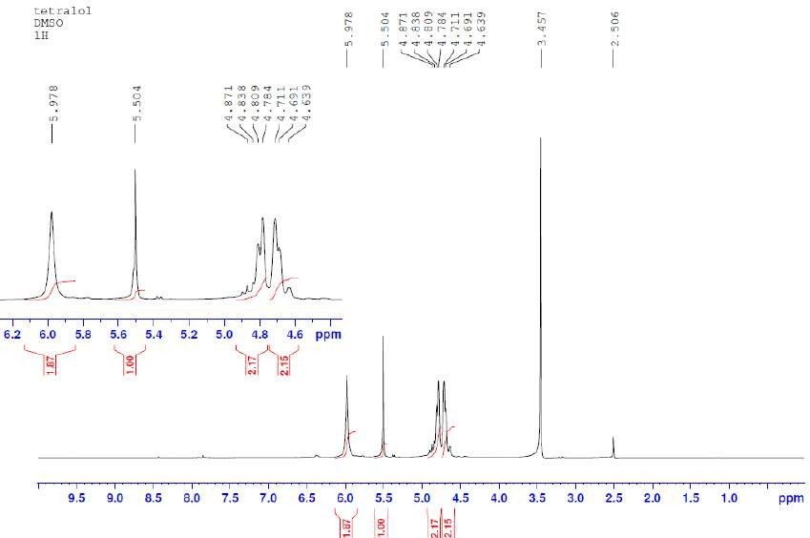
Figure 2. TGMGU 1H spectra.

Specter NMR 13C (Figure 3) (100 MHz, DMSO-d₆), 8 ppm: 157.48 (C=O), 87.03 (CH-
CH), 65.10 (N-CH₂).
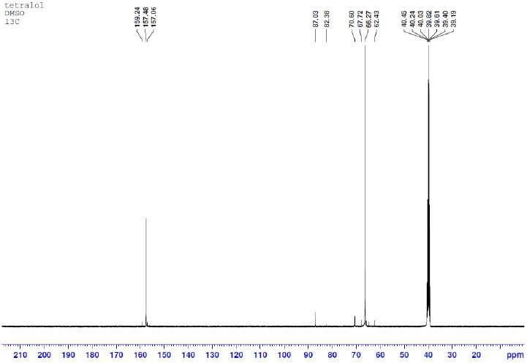
Figure 3. TGMGU 13C spectra.
IR specter, v, cm−1: 1703 (C-O), 3273 (OH).
  - Betulin (BET) Separation
Betulin (BET) was separated through extraction from birch tree bark using the standard procedure [11]. The obtained substance was recrystallized from isopropyl alcohol and characterized using IR and NMR spectroscopy.
The IR specter (KBr, ν, cm–1) of betulin is characterized by absorption bands in the 3368 cm–1 area, which is typical for –OH groups, 1646 cm–1 (C=C) and others: 2968–2864
(C–H), 1450, 1372, 1105, 1029, 878.
1H NMR (400,17 MHz, CDCl₃, δ, ppm): the weaker fields area has isopropenyl group proton signals (4.51 and 4.61 ppm); 3.26 and 3.73 (p, 2H, C₂₈H₂-OH); 3.10–3.14 (m, 1H, C₃H-OH); 2.28–2.35 (m, 1H, C₁₉–H); in the 0.79–2.00 ppm area there are lupane skeleton proton signals, where C-H group proton signals are found in betulin structure (6CH₃, 10CH₂, 5CH).
13C NMR (100,63 MHz, CDCl₃, δ, m.f.): 150,51 (C-20); 109,71 (C-29); 78,98 (C-3); 64,46
(C-17); 60,51 (C-28); 55,28 (C-5); 50,38 (C-9); 48,74 (C-18); 47,79 (C-19); 42,71 (C-14); 40,91
(C-8); 38,87 (C-4); 38,69 (C-1); 37,30 (C-13); 37,15 (C-10); 34,22 (C-22); 33,98 (C-7); 29,74
(C-16); 29,16 (C-21); 27,99 (C-15); 27,38 (C-2); 27,04 (C-12); 25,37 (C-23); 25,19 (C-24); 20,83
(C-11); 19,09 (C-30); 18,30 (C-6); 16,12 (C-25); 15,98 (C-26); 15,38 (C-27).
  - Obtained Materials Characterization Methods
    - Nuclear Magnetic Resonance (NMR) Spectroscopy
NMR specters of synthesized compounds were registered on an NMR spectrometer Bruker Avance 400 III HD in DMSO-d6 solution at 25 ◦C, working frequency at hydrogen nuclei—400 MHz, at 13C—100 MHz.
    - Infrared (IR) Spectroscopy
Sample research was performed using IR spectroscopy with Fourier transform with an IR spectrometer Nicolet 6700, Thermo Fisher Scientific. Sample research was performed using the attenuated total reflectance method within a specter range between 400 and

4000 cm–1 with resolution 4 cm–1. Obtained reflectance specters were transformed into absorption bands using Kubelka–Munk transformation.
    - Scanning Electron Microscopy (SEM) and Energy Dispersive X-ray Spectroscopy (EDS)
The JSM-IT200 is an easy-to-use compact scanning electron microscope, which enables the user to quickly and easily perform SEM analysis. The electron optics system, achieving a resolution of 3.0 nm at an accelerating voltage of 30 kV, is useful for a variety of applications, from high-resolution observation to EDS analysis. Specimen Exchange Navi, a beginner-friendly function, offers guided operation from sample loading to area search, and SEM image observation. Fully integrated EDS (silicon drift detector, resolution: 130 eV) includes “live EDS analysis”, displaying the chemical composition of the specimen while imaging. With the “Zeromag” function, sample navigation is easier than ever before. “Zeromag”, which links the SEM image with Holder Graphics or an optical CCD image, enables you to quickly locate areas for imaging and analysis.
    - X-ray Photoelectron Spectroscopy (XPS) Analysis
For XPS analysis, we used a Nexsa X-Ray Photoelectron Spectrometer (XPS) by Thermo Scientific, which is a multi-technique surface chemistry analysis system. The main specifi-cations of the Nexsa XPS system are as follows: sampling area: 3600 mm2 (samples must be smaller than a 60 × 60 mm sample holder); max. sample thickness: 20 mm; X-ray spot size: 10–400 µm (adjustable in 5 µm steps); analyzer type: 180◦, double-focusing, hemispherical analyzer with 128-channel detector; depth profiling: EX06 monatomic ion source; and X-ray source type: monochromated low-power Al Ka X-ray source—1486.6 eV.
  - Biocomposite Hemocompatibility Evaluation
One of the ways to evaluate general cytotoxicity is to study hemolytical activity. Hemolysis is a process of hemoglobin release as a result of erythrolysis. The test for material hemolytical activity is based on erythrolysis and the hemoglobin dissociation degree during material contact with erythrocytes in vitro [12].
In order to evaluate hemocompatibility, whole hemostated blood from a healthy donor was used. After centrifuging, the blood was separated and erythromass was isolated. Obtained erythromass was diluted with sterile 1X PBS solution at 37 ◦C to a 1:9 ratio. Then, samples were placed into a standard 12-slot tray for cell cultivation and the obtained blood solution with PBS was poured at the ratio of 1 mln per 1 cm2 of sample surface area. As a positive control to define reaching 100% hemolysis, deionized water was used; as negative control, 1X PBS solution was used, which provides 0% hemolysis. During the experiment, IDA and CDA were used as control materials. Then, the tray with the samples was incubated in thermostat at 37 ◦C for 60 min. Next, the contents of the tray slots were transferred to centrifugal tubes and remaining erythrocytes were spun down by centrifugation for 5 min at 3000 rpm. Then, the supernatant was carefully removed and transferred to a standard 96-slot tray for further spectroscopy. The samples’ optical density
was measured using the EIA reader TecanInfiniteF50 (Tecan Inc., Morrisville, NC, USA) at 492 nm.
The hemolysis percentage was the average value of three replications and was calcu-lated using the formula given in GOST [12]:

ODtest − ODnegative

Hemolysis, % =
positive
control
× 100%

ODcontrol − ODnegative
control

  - Evaluation of Plasma Protein Adsorption by Biocomposites
In order to analyze plasma protein adsorption in studied samples, a modified method of solution depletion was used. This method includes two quantitative definitions of finding the protein concentration in blood plasma—before and after sample incubation [13].

We used the biuret reaction method to determine the amount of protein in solution.
This method was chosen because of its simplicity and relative accuracy [14,15].
Initial plasma was separated from whole hemostated blood of a healthy donor by centrifugating. Then, the protein content in the plasma was found using the biuret reaction. Samples were filled with 2 mL of plasma and incubated at 37 ◦C in thermostat for 24 h. After incubation, the protein concentration was found a second time. The difference between the protein concentration of the initial plasma and that after incubation allows us to evaluate the protein adsorption rate—the greater this difference, the more protein that was adsorbed on the sample surface.
The interaction of blood serum proteins with cupric sulphate in a basic environment leads to the formation of complex compounds of purple color due to the proteins’ pep-tide bonds with copper ions. The intensity of the solution color depends on its protein concentration.
After the samples’ incubation and separation from the solution, the biuret reaction was carried out, followed by optical density measurement. To do this, 5.0 mL of working biuret reagent solution was added to 0.1 mL of blood plasma and carefully stirred, avoiding foam formation. The control experiment was performed simultaneously and 0.1 mL of 0.9% sodium chloride solution was used as control, then adding 5 mL of working biuret reagent solution. Then, 30 min later (but no later than 1 h), the solution optical density was measured using the EIA reader Tecan Infinite F50 (Tecan Inc., Morrisville, NC, USA) at 492 nm wavelength against control.
  - Biocomposite Antimicrobial Activity Evaluation
To evaluate the antibacterial activity of created samples, a standard disc diffusion method modified by the authors of this study was used. According to this method, the samples were placed on the surface of a high-density agar environment. CHL, BET and TGMGU (chloramphenicol, betulin and tetrahydroxymethylglycoluril) modifiers diffused into the environment, creating areas of bacteria growth suppression.
To study samples’ impact on the microflora, the Escherichia coli ATCC 25922 strain was used as test object. Escherichia coli was chosen as a model object because of the high importance of this microorganism for agriculture and medicine. The media used for E. coli cultivation were the standard LB media for these bacteria, containing peptone (10 g/L), yeast extract (5 g/L), sodium chloride (10 g/L) and microbiological agar (1.5–2% by volume).
Incubation was carried out in thermostat at 37–38 ◦C for 24 h.
Each Petri dish with 15 mL of concentrated nutritious environment was inoculated with E. coli using lawn inoculation and pure bacteria culture. The volume of inoculum applied was 0.1 mL (0.5 McFarland’s standard, 108 microorganisms/mL). Then, the sample was placed in the center of the dish. After incubation, the diameter of the zone with suppressed bacteria growth was measured to an accuracy of 0.1 mm. A large area of bacteria growth suppression implied a higher antibacterial activity of the sample. A bacteria growth inhibition area was considered one where growth was completely suppressed.
Samples without CHL in IDA and CDA were used as negative control. Samples modified by submersion into chloramphenicol solution (IDA + CHL and CDA + CHL) were used as positive control.
  - Statistical Analysis
Statistical analysis was performed using STATISTICA 8.0 for Windows (STATISTICA, RRID: SCR_014213). The Mann–Whitney test and t-test for independent groups were implemented. The data were checked for normality of distribution using the Shapiro–Wilk statistical criterion. Results were considered to be significant with *** p < 0.001, ** p < 0.01 and * p < 0.05.

Results and Discussion
Chloramphenicol (CHL) is an antibiotic used for treating bacterial infections. However, its use has been limited in recent decades due to its high systemic toxicity [16]. In this study, CHL was chosen as a model antibacterial compound because the test strain E. coli is highly sensitive to it.
Another substance used as a model antibacterial compound was tetrahydroxymethyl-glycoluril (TGMGU)—a nitrogen-containing heterocycle, one of bicyclic bis-ureas. As more bacteria strains become resistant to anti-bacterial compounds, those with biocidal prop-erties become particularly interesting. TGMGU gradually releases formaldehyde, which causes its antibacterial properties. Also, TGMGU is used in medicine as a biomaterial component to improve fixation, keeping tissues’ and cells’ structure [13].
The third model compound was betulin (BET)—pentacyclic triterpenoid extracted from birch tree bark. Betulin and its derivatives possess various bioactive properties, including wound-healing, antibacterial, antitumoral, hypolipidemic, hepatoprotective and antiviral properties [17]. Betulin (BET) also can overcome resistance and induce apoptosis in malignized cells in various human cancer diseases. It displays antibacterial activity against Bacillus subtilis and Escherichia coli, and highly inhibits urease activity of Helicobacter pylori [17,18].
Moreover, BET wound-healing properties are caused by its ability to increase cell migration to damaged areas, increase their survival ability and stimulate collagen synthe-sis [19]. This wide range of biological activity suggests that BET can compensate for the toxic impact of antibacterial compounds, and combined with other antibacterial agents it can display synergy and increase their activity.
According to the stated objective, we studied the hemocompatibility and synergetic antibacterial activity of the composite materials. The following were used in this study as surface modifiers: chloramphenicol (CHL), betulin (BET) and tetrahydroxymethylglycoluril (TGMGU); their structures are shown in Figure 4.


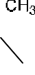

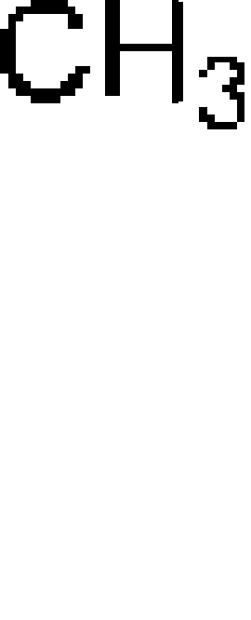
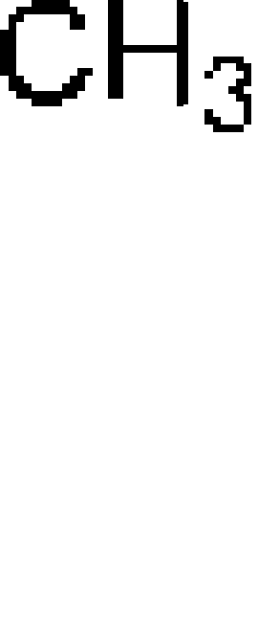
Figure 4. DA surface modifier structures: CHL—chloramphenicol; BET—betulin; TGMGU—tetrahydroxymethylglycoluril. In order to add modifiers, a DA sample was submerged into a working solution for 40 min (Figure 5). Working solutions were prepared as follows. For CHL, a 3% solution in ethyl alcohol was used to obtain the IDA + CHL and CDA + CHL composites. To obtain the IDA + CHL + BET and CDA + CHL + BET composites, 15 mg of BET was added to a 3% solution of CHL in ethanol. Solutions for obtaining composites with TGMGU were prepared in an ethanol solution with a concentration of each substance (TGMGU and BET) of 1 mg/1 mL. The resulting solutions were taken in an amount of 15 mL per sample. There also was a control experiment, where distilled water was used instead of bioactive solution. Obtained materials were completely dried at room temperature and studied for their biological activity.

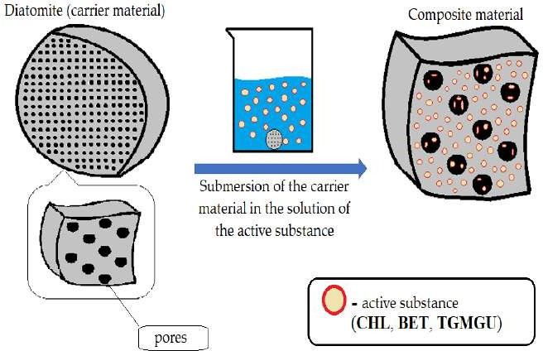
Figure 5. Illustration of bioactive substance (CHL, BET, CHL + TGMGU, BET + TGMGU) application onto DA.
For each obtained sample (IDA with CHL, CHL + BET, TGMGU, TGMGU + BET and CDA with CHL, CHL + BET, TGMGU, TGMGU + BET), the IR specter was measured. IR specters of substance (complex compounds) absorption were obtained using the IR Fourier spectrometer Nicolet 6700 with FTIR console on a diamond crystal (resolution 4 cm−1, 64 scans, range—4000–450 cm−1); no visible sample decomposition was observed. To obtain IR spectra, the samples were dried to a constant weight, and scanning was from the surface of the composites.
The IDA with CHL sample specter (Figure 6a) showed the following absorption bands related to diatomite stretching vibrations—451, 816 and 1060 cm−1. The rest of the specter showed CHL absorption bands: stretching vibrations of OH-group were seen at 3480 cm−1, NH-groups of secondary amine at 3260 cm−1, C-H aromatic ring at 3080 cm−1 and C=O at 1680 cm−1, as well as nitrogroup stretching vibration absorption bands at 1560 cm−1. All the IR spectroscopy data set suggested CHL presence on IDA surface.
When analyzing the IR specter of IDA with CHL and BET fracture plane (Figure 6a), there were additional absorption bands typical for betulin—C-H stretching vibrations of the lupane skeleton at 2870, 2930 and 2970 cm−1. At 3480 cm−1, there was absorption band broadening as there was interference of the BET, CHL and DA OH-groups. All the IR spectroscopy data set proved BET presence in the composite. The IR spectra of the CDA samples (Figure 6b) showed a similar pattern.
In addition to IR spectroscopy, these samples were analyzed using SEM, EMF and XPS. To carry out the analysis, the samples were dried at room temperature to constant weight. The analysis was carried out from the surface of the scaffolds, which are circular in shape, 2 cm in diameter and 2 mm thick. The surface of the IDA is visible on the SEM images (Figure 7). An EDS was carried out from this surface (Figure 8), which showed that carbon is present on the surface in addition to the constituent elements of DA (silicon and oxygen). The X-ray photoelectron spectroscopy (XPS) analysis of these composite materials pro-vided information about the elemental composition and chemical bonding of the molecules. Since IDA and CDA contain only silicon and oxygen (other than metals), atoms will appear in the presence of organic substances (Figure 9), for example, nitrogen. The combination of these factors confirms the presence of CHL in the sample. Common acquisition parameters
of the experiments were as follows: source gun type—Al K Alpha; spot size—400 µm; analyzer mode—CAE: Pass Energy 50.0 eV; and energy step size—0.100 eV.

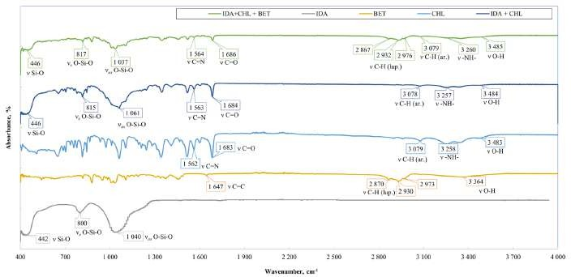
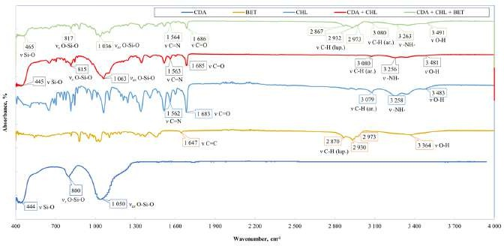
(a)
(b)
Figure 6. (a) Comparative specters of CHL samples and CHL/BET mixture on IDA. (b) Comparative specters of CHL samples and CHL/BET mixture on CDA.
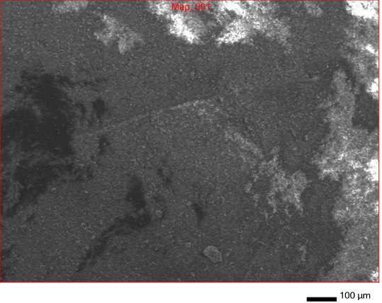
Figure 7. SEM surface of IDA + CHL composite.

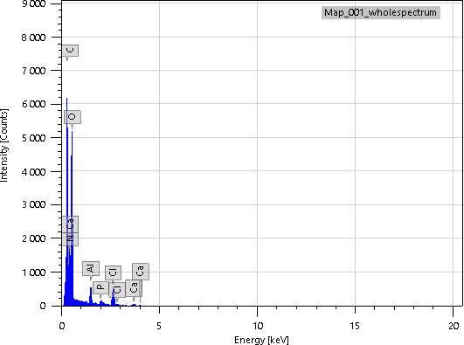
Figure 8. EDS of IDA + CHL sample surface.
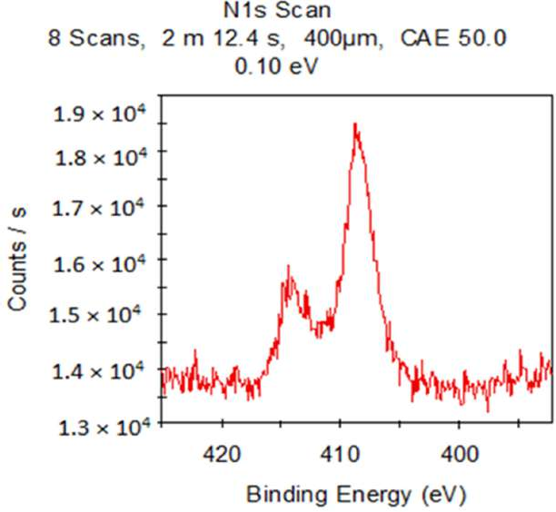
Figure 9. XPS of IDA + CHL sample.

Samples with cleaned diatomite provided a similar picture. All the typical absorption bands for the CHL and BET functional groups had the same positions (Figure 10).

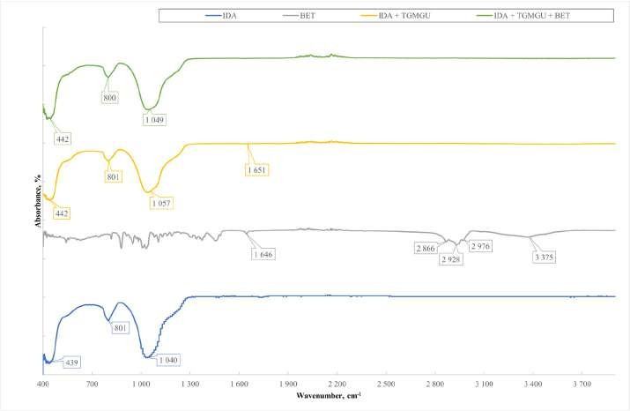
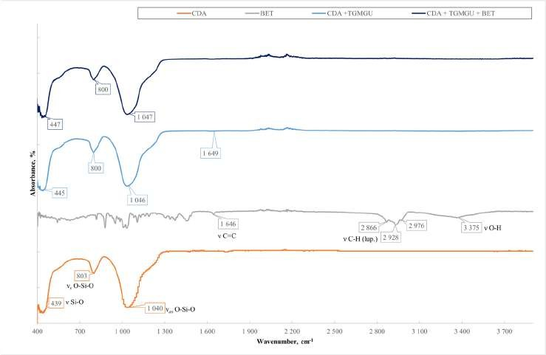
(a)
(b)
Figure 10. (a) Comparative specters of TGMGU and TGMGU/BET mixture materials on IDA.
(b) Comparative specters of TGMGU and TGMGU/BET mixture materials on CDA.
Samples with TGMGU and TGMGU/BET mixtures were also analyzed using IR spec-troscopy and X-ray photoelectron spectroscopy. Absorption maximums earlier identified for DA were also seen in the IR specters of these obtained materials. In the IDA + TGMGU sample section, there were no absorption bands typical for TGMGU (Figure 10a), but the samples still displayed a distinctive antibacterial activity (Table 6). The IR specter also had absorption bands at 1638 cm−1, which might be related to formaldehyde presence in the sample. The IR spectra of the CDA samples (Figure 6b) showed a similar pattern [20].
The experiment observations were obviously related to the fact that TGMGU can extendedly separate formaldehyde in water solution [15]. Formed formaldehyde tends to bind with the DA surface and provide antibacterial effect, while the rest of the TGMGU does not remain due to high water solubility [21,22]. Another fact that suggests this is that in the SEM scan (Figure 11) no TGMGU or fragments thereof can be seen. The presence

of free formaldehyde on the IDA + TGMGU sample surface can also be suggested from X-ray photoelectron spectroscopy scans (Figure 12). Considering the data (Figure 12) for carbon distribution on the IDA surface, a carbon-containing organic substance can be seen. Moreover, according to the SEM data, there were no nitrogen atoms on the IDA + TGMGU surface, as could be expected due to the use of TGMGU.
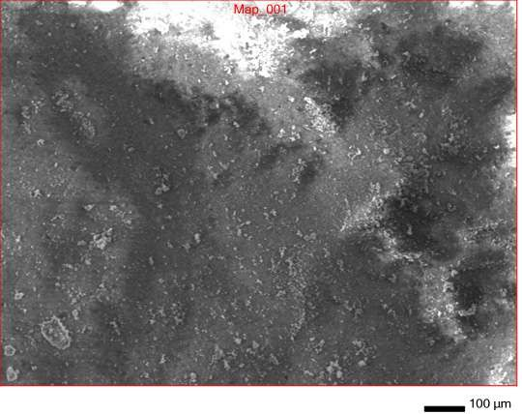
Figure 11. SEM surface of IDA + TGMGU composite.
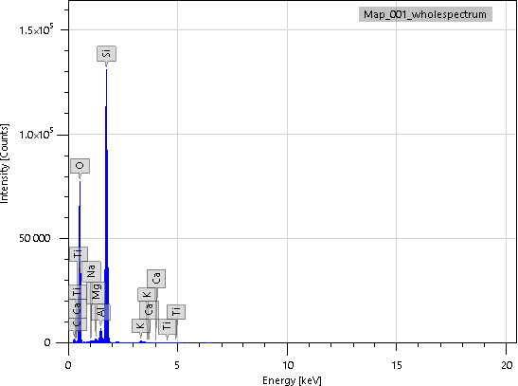
Figure 12. EDS of IDA + TGMGU sample surface.

In the X-ray photoelectron spectroscopy (XPS) analysis of these composite materials, in addition to the basic atoms (carbon and oxygen), the binding energy with nitrogen is observed (Figure 13).

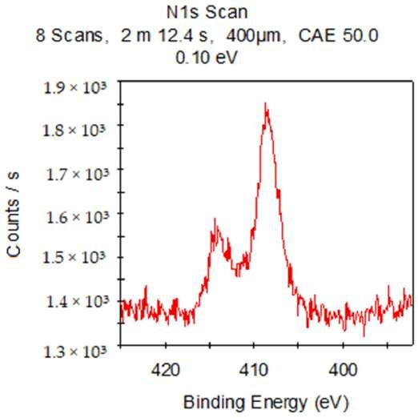
Figure 13. XPS of IDA + TGMGU sample.

Samples with cleaned diatomite produced a similar picture. The IR specters (Figure 10) did not show absorption bands; however, similar to the IDA + TGMGU composites, there were absorption bands typical for DA.
These facts were also proven by SEM scan (Figure 14). Considering the X-ray pho-toelectron spectroscopy scans (Figure 15), carbon distribution on the surface can be seen, which suggests the presence of a carbon-containing organic substance (Figure 15), similar to the IDA + TGMGU composites.
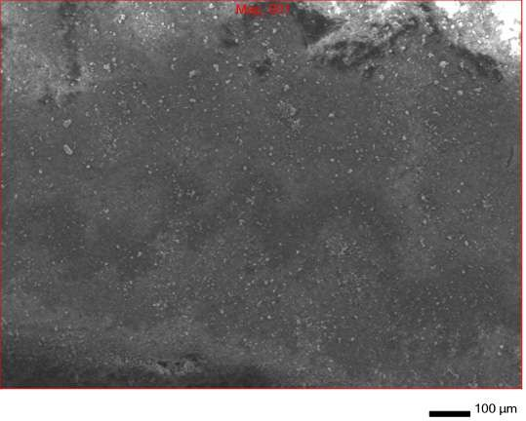
Figure 14. SEM scan of CDA + TGMGU composite surface.

Map_001_wholespectrum

1.5*10⁵

1.0*10⁵

50,000

0
0 5 10 15 20
Energy [keV]
Figure 15. EDS scans of CDA + TGMGU sample surface.

The X-ray photoelectron spectroscopy (XPS) analysis of this composite produced a similar picture (Figure 16).

N1s Scan
8 Scans, 2 m 12.4 s, 400µm, CAE 50.0
0.10 eV
1.80E+04

1.70E+04

1.60E+04
Counts / s

1.50E+04

1.40E+04

1.30E+04

1.20E+04

420

410

400

Binding Energy (eV)
Figure 16. XPS of CDA + TGMGU sample.

Based on the obtained data, a TGMGU and diatomite surface interaction pattern was produced (Figure 17).
The presence of BET on the composite surfaces can be suggested from SEM scans of IDA + TGMGU + BET (Figure 18a) and CDA + TGMGU + BET (Figure 18b). In these cases, BET is present as a dispersion in water solution and its crystals can be seen in the SEM scans—needle-shaped crystals on the surface marked with red rectangles.

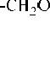
Figure 17. TGMGU and DA surface interaction pattern.
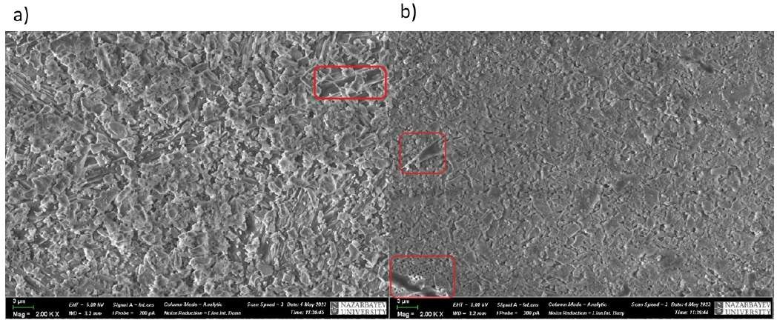

Figure 18. SEM scans of samples of IDA + BET (a) and CDA + BET (b).

After having studied the obtained composites IDA + CHL, IDA + CHL + BET, IDA + TGMGU, IDA + TGMGU + BET, CDA + CHL, CDA + CHL + BET, CDA + TGMGU
and CDA + TGMGU + BET, we studied the toxic impact of the obtained biocomposites, which was estimated by studying their hemocompatibility, plasma protein adsorption and antibacterial activity.
One of the ways to estimate general material cytotoxicity is to study hemolytical activity.
Table 1 shows the hemolytical activity level estimation results for the sample groups DA + CHL + BET, which suggested that the modified CHL and BET samples did not display any hemolytical activity.
The absence of hemolytical activity in the studied composite samples may be related to the fact that during the DA treatment with CHL and BET, the base component’s porosity decreases. According to reference data, hemolysis on inert biomaterial surfaces is directly connected to plasma protein adsorption, and particularly to fibrinogen on the surface of the material being in contact with blood [23]. In other words, the more adsorption of plasma proteins there is, the greater the amount of hemolysis. Diatomite is a porous material with small pore size, at least they are smaller than the size of protein molecules, so plasma

protein adsorption is insignificant on it [24]. Considering the abovementioned, it can be suggested that this is the reason for the low hemolysis level on these composites.

Table 1. Hemocompatibility level for samples IDA, HA + CHL and HA + CHL + BET, CDA + CHL, CDA + CHL + BET, CDA + TGMGU, CDA + TGMGU + BET.

№ | Sample | Hemolysis, %
1 | IDA | 0
2 | CDA | 0
3 | IDA + CHL | 0
4 | CDA + CHL | 0
5 | IDA + CHL + BET | 0
6 | CDA + CHL + BET | 0
7 | CTRL 100% | 100
8 | CTRL 0% | 0
Note: IDA—intact diatomite; CDA—cleaned diatomite; CHL—chloramphenicol; CTRL—control sample with pre-set hemolysis percentage.

In order to determine whether the hemolytical activity level was connected to the plasma protein adsorption level in the studied samples, we studied the degree of the decrease in plasma proteins concentration after incubation with the samples obtained during the research using a modified solution depletion method.
As Table 2 suggests, all samples, including control ones (IDA and CDA), showed decreased protein in plasma after incubation, which was proven statistically (p < 0.05). Samples from the group CDA + CHL, as well as IDA and CDA, displayed the highest adsorption, but statistically no proven differences were found between them (p > 0.05). Other samples (IDA + CHL, IDA + CHL + BET and CDA + CHL + BET) also showed decreased protein content in solution (p < 0.05).

Table 2. Level of plasma protein adsorption by samples IDA, HA + CHL and HA + CHL + BET, CDA + CHL, CDA + CHL + BET, CDA + TGMGU, CDA + TGMGU + BET.

№ | Sample | Optical Density | ∆ of Optical Density
1 | IDA | 0.1386 ± 0.0133 | 0.1227
2 | CDA | 0.1366 ± 0.0053 | 0.1247
3 | IDA + CHL | 0.1853 ± 0.0112 | 0.0847
4 | CDA + CHL | 0.1379 ± 0.0097 | 0.1321
5 | IDA + CHL + BET | 0.2049 ± 0.0318 | 0.0651
6 | CDA + CHL + BET | 0.1732 ± 0.0238 | 0.0968
7 | CTRL (PBS) | 0.1228 ± 0.0059 | 0.1472
8 | CTRL (PLASMA) | 0.2700 ± 0.0164 | -
Note: IDA—intact diatomite; CDA—cleaned diatomite; CHL—chloramphenicol; BET—betulin; CTRL (PBS)—blank test; CTRL (PLASMA)—protein content in intact plasma.

Supposedly, the low levels of the studied composites’ adsorption was related to the low hemolysis level and, consequently, low protein adsorption, the level of which was beyond the sensitivity of the method used. It was found that the betulin presence in the samples IDA + CHL + BET and CDA + CHL + BET also did not influence adsorption. Probably, the decrease in protein concentration after incubation may be connected not to surface adsorption but more to high porosity and the generally high sorption capacity of the studied samples.

As Table 3 suggests, the not modified with chloramphenicol (CHL) samples of the negative controls (IDA and CDA) did not display antibacterial effect in this method. Positive control group samples (IDA + CHL and CDA + CHL) displayed the highest antibacterial activity among all samples (51,0 and 52,1 mm, respectively). The antibacterial activity of the CDA + CHL samples was higher, but there were no statistically proven differences between them (p > 0.05). Betulin presence in samples did not influence the general antibacterial activity (p > 0.05).

Table 3. Antibacterial activity level of samples IDA, HA + CHL and HA + CHL + BET, CDA + CHL, CDA + CHL + BET, CDA + TGMGU, CDA + TGMGU + BET.

№ | Sample | Growth Suppression Area Diameter, mm
1 | IDA | 0
2 | CDA | 0
3 | IDA + CHL | 51.0 ± 0.8
4 | CDA + CHL | 52.1 ± 0.5
5 | IDA + CHL + BET | 50.9 ± 0.6
6 | CDA + CHL + BET | 49.8 ± 1.1
Note: IDA—intact diatomite; CDA—cleaned diatomite; CHL—chloramphenicol; BET—betulin.

According to our hypothesis, due to the high content of other natural mineral com-pounds and higher porosity, intact diatomite (IDA) would display higher antibacterial activity; however, no difference was found between intact and cleaned diatomite. Probably, this is connected to the high sensitivity to chloramphenicol (CHL) of the test strain used. The high background activity of chloramphenicol (CHL) did not allow us to find the fine differences in antibacterial activity in the created biocomposites due to the limitations of the disc diffusion method used.
Diatomites modified with TGMGU and BET displayed different levels of activity (Table 4).
Table 4. Hemocompatibility level of samples IDA, HA + CHL and HA + CHL + BET, CDA + CHL, CDA + CHL + BET, CDA + TGMGU, CDA + TGMGU + BET.

№ | Sample | Hemolysis, %
1 | IDA | 0
2 | CDA | 0
3 | IDA + TGMGU | 0
4 | CDA+ TGMGU | 0
5 | IDA+ TGMGU +BET | 0
6 | CDA+ TGMGU +BET | 2.1122 ± 0.0026
7 | CTRL 100% | 100
8 | CTRL 0% | 0
Note: IDA—intact diatomite; CDA—cleaned diatomite; TGMGU—tetrahydroxymethylglycoluril; BET—betulin.

As Table 4 suggests, the highest hemolysis level was shown by the CDA + TGMGU + BET samples (2.1122 ± 0.0026%) (p < 0.05). Other group samples did not display hemolyt-ical activity (Table 4). Probably, the absence of hemolytical activity in these groups was connected to the high initial biocompatibility of diatomite, which is proven by reference data [4].
It was also found that a slightly higher hemolysis level was displayed by the CDA sample containing betulin (CDA + TGMGU + BET). Probably, this happened due to higher protein adsorption on the sample surface under betulin influence. However, it should be

noted that the hemolysis level of biomaterials contacting the milieu interieur should not exceed 5% [12]. As the experiment shows, none of the studied samples exceeded this level, which shows that all the composite samples were hemocompatible.
It should be noted that the problem of unwanted blood clotting at contact with implanted materials and devices is still unsolved. The cause of this is the fact that healthy vessel endothelium has mechanisms resisting thromb formation, but foreign objects (i.e., foreign to the human body) do not have such defense mechanisms. Instead, biomaterials promote blood clotting through activating a number of interconnected processes including protein adsorption, thrombocyte and leukocyte adhesion, the production of thrombin and complement activation [23]. Due to this, the search for antibacterial substances that modify biocompatible materials but do not increase the hemolysis percentage is of high importance.
It should also be noted that the cytocompatibility control method tested in this study was successful as a reliable express method for general material cytotoxicity control. None of the samples exceeded the hemolysis level for medical materials contacting blood, accord-ing to ISO 10993-4:2017 [12].
As Table 5 suggests, the lowest adsorption level was displayed by the CDA + TGMGU
+ BET and IDA + TGMGU + BET samples, but no statistically proven differences between them were found (p > 0.05).

Table 5. Protein content in plasma after incubation.

№ | Sample | Optical Density | ∆ Optical Density
1 | IDA | 0.1386 ± 0.0133 | 0.1227
2 | CDA | 0.1366 ± 0.0053 | 0.1247
3 | IDA + TGMGU | 0.1854 ± 0.0154 | 0.0846
4 | CDA + TGMGU | 0.1891 ± 0.0235 | 0.0809
5 | IDA + TGMGU + BET | 0.2423 ± 0.0147 | 0.0277
6 | CDA + TGMGU + BET | 0.2322 ± 0.0207 | 0.0378
7 | CTRL (PBS) | 0.1228 ± 0.0059 | 0.1472
8 | CTRL (PLASMA) | 0.2700 ± 0.0164 | -
Note: IDA—intact diatomite; CDA—cleaned diatomite; TGMGU—tetrahydroxymethylglycoluril; BET—betulin; CTRL (PBS)—blank test; CTRL (PLASMA)—protein content in intact plasma.

According to experiments previously performed in our study for hemocompatibility, the research sample CDA + TGMGU + BET displayed the highest hemolysis in the series of samples. However, the hemolysis level of this sample was 2.1122 ± 0.0026%, which suggests low hemolytical activity. However, the protein adsorption level for this sample was low. Probably, the treatment of the porous materials clogged their pores and reduced the sorption capacity, and the differences in adsorption level were connected directly to the samples’ physical structure.
Supposedly, a low adsorption level was related to a low hemolysis level and, con-sequently, low protein adsorption, the level of which was beyond the used method’s sensitivity. The presence of betulin (BET) in a sample also influences adsorption. Probably, the reduction in protein concentration after incubation was connected not to surface ad-sorption but more to high porosity and the generally high sorption capacity of the studied samples.
With respect to the antibacterial activity of composite DA + TGMGU, as Table 6 sug-gests, samples IDA + TGMGU and CDA + TGMGU also displayed antibacterial activity (27.9 and 31,9 mm, respectively), but no statistically proven differences between them were found (p > 0.05). But it can be noted that in the case of samples’ modification with betulin, the levels of activity changed. Samples IDA + TGMGU + BET and CDA + TGMGU + BET had growth suppression area diameters of 33,8 and 27,2 mm, respectively. The activity

of sample IDA + TGMGU + BET was slightly higher, which was statistically proven (p < 0.05).

Table 6. Antibacterial activity level of samples IDA, HA + CHL and HA + CHL + BET, CDA + CHL, CDA + CHL + BET, CDA + TGMGU, CDA + TGMGU + BET.

№ | Sample | Growth Suppression Area Diameter, mm
1 | IDA | No activity
2 | CDA | No activity
3 | IDA + TGMGU | 27.9 ± 0.6
4 | CDA + TGMGU | 27.2 ± 1.0
5 | IDA + TGMGU + BET | 33.8 ± 1.2
6 | CDA + TGMGU + BET | 31.9 ± 1.1
Note: IDA—intact diatomite; CDA—cleaned diatomite; TGMGU—tetrahydroxymethylglycoluril; BET—betulin.

Conclusions
As we hypothesized, betulin as a bioactive compound will increase the antibacterial effect of TGMGU. This increase may also be due to the high porosity of intact diatomite (IDA) and the other natural mineral compounds present. In the case of intact diatomite (IDA) without betulin, the TGMGU activity is slightly lower, which was statistically proven (p < 0.05). However, the differences between the samples with and without betulin, although statistically proven, were not great in absolute values. Supposedly, this is connected to the test strain’s non-specific resistance to tetrahydroxymethylglycoluril. Probably, the test strain should be later replaced with another one, for example, Bacillus subtilis, which is subject to further research. It can also be assumed that the lack of additional antimicrobial effect in samples containing betulin may be due to the low solubility of betulin in water.
It should be noted that betulin is a natural compound with multiple potentially useful properties, although these are not currently researched. Supposedly, the increase in the biological activity of other active compounds is achieved not due to direct synergetic impact directly on bacteria, but due to the activation of complex interaction processes with other substances inside the human body and the enforcement of natural defense reactions. In the future, we plan to expand the number of test strains, antibacterial compounds and betulin derivatives used. These will be the subject of further research.

Author Contributions: Conceptualization, S.K., G.Z. (Gaziza Zhumanazarova) and A.U.; Methodol-ogy, A.U., O.Y. and K.I.; Software, F.T.; Validation, G.Z. (Gulistan Zhumabayeva); Formal analysis, S.K., G.Z. (Gulistan Zhumabayeva) and R.Y.; Investigation, R.Z., D.F., A.G. and F.T.; Resources, D.F., F.T. and O.Y.; Data curation, S.K., D.F., O.Y. and R.Y.; Writing—original draft, G.Z. (Gaziza Zhumanazarova) and A.G.; Writing—review and editing, G.Z. (Gaziza Zhumanazarova) and K.I.; Su-pervision, S.K., O.Y. and R.Y.; Project administration, A.B.; Funding acquisition, S.K. and G.Z. (Gaziza Zhumanazarova). All authors have read and agreed to the published version of the manuscript.
Funding: This research was funded by the Russian Science Foundation, grant RSF 24-43-20044, and the Tomsk State University Development Program (Priority-2030), Russia.
Institutional Review Board Statement: The study was conducted in accordance with the Declaration of Helsinki and approved by the Bioethics Committee of Research, Tomsk State University, dated 20 November 2023, Project identification code—18.
Informed Consent Statement: Informed consent was obtained from all subjects involved in the study.
Data Availability Statement: Data are contained within the article.
Conflicts of Interest: The authors declare that they have no known competing financial interests or personal relationships that could have appeared to influence the work reported in this paper.

References
- Vikhrov, S.; Kholomina, T.; Begun, P.; Afonin, P. Biomedical Materials Science: A Tutorial for Universities; Hotline—Telecom: Moscow, Russia, 2006.
- Manabu, S. Medical Polymers; Medicine: Moscow, Russia, 1981.
- Kulinets, I. Biomaterials and Their Applications in Medicine. Regul. Aff. Biomater. Med. Devices 2015, 1–10. [CrossRef]
- Ghobara, M.M.; Ghobara, M.M.; Ghobara, M.M.; Mohamed, A. Diatomite in Use: Nature, Modifications, Commercial Ap-plications and Prospective Trends. In Diatoms: Fundamentals and Applications; John Wiley & Sons, Ltd.: Hoboken, NJ, USA, 2019;
pp. 471–509. [CrossRef]
- Diatomaceous Earth|Uses, Benefits & Safety|Britannica. Available online: https://www.britannica.com/science/diatomaceous-earth (accessed on 30 September 2023).
- Sprynskyy, M.; Pomastowski, P.; Hornowska, M.; Król, A.; Rafin´ska, K.; Buszewski, B. Naturally Organic Functionalized 3D Biosilica from Diatom Microalgae. Mater. Des. 2017, 132, 22–29. [CrossRef]
- Korsunsky, A.M.; Sapozhnikov, P.V.; Everaerts, J.; Salimon, A.I. Nature’s Neat Nanostructuration. Mater. Today 2019, 22, 159–160. [CrossRef]
- Choi, Y.; Banerjee, A.; McNish, S.; Couch, K.S.; Torralba, M.G.; Lucas, S.; Tovchigrechko, A.; Madupu, R.; Yooseph, S.; Nelson, K.E.; et al. Co-Occurrence of Anaerobes in Human Chronic Wounds. Microb. Ecol. 2019, 77, 808–820. [CrossRef] [PubMed]
- Goren, R.; Baykara, T.; Marsoglu, M. A Study on the Purification of Diatomite in Hydrochloric Acid. Scand. J. Metall. 2002, 31, 115–119. [CrossRef]
- Petersen, H. Syntheses of Cyclic Ureas by α-Ureidoalkylation. Synthesis 1973, 1973, 243–292. [CrossRef]
- Demets, O.V.; Takibayeva, A.T.; Kassenov, R.Z.; Aliyeva, M.R. Methods of Betulin Extraction from Birch Bark. Molecules 2022, 27, 3621. [CrossRef] [PubMed]
- ISO. ISO 10993-4:2017; Biological Evaluation of Medical Devices, Part 4: Selection of Tests for Interactions with Blood. ISO: Geneva, Switzerland, 2017. Available online: https://www.iso.org/standard/63448.html (accessed on 29 September 2023).
- Burtis, C.A.; Bruns, D.E.; Sawyer, B.G.; Tietz, N.W. Tietz Fundamentals of Clinical Chemistry and Molecular Diagnostics, 7th ed.; Elsevier/Saunders: St. Louis, MO, USA, 2015.
- Wiest, D.B.; Cochran, J.B.; Tecklenburg, F.W. Chloramphenicol Toxicity Revisited: A 12-Year-Old Patient with a Brain Abscess. J. Pediatr. Pharmacol. Ther. 2012, 17, 182–188. [CrossRef] [PubMed]
- Rose, A.; Funk, D.; Neiger, R. Comparison of refractometry and biuret assay for measurement of total protein concentration in canine abdominal and pleural fluid specimens. J. Am. Vet. Med. Assoc. 2016, 248, 789–794. [CrossRef] [PubMed]
- Holt, D.; Harvey, D.; Hurley, R. Chloramphenicol toxicity. Adverse Drug React. Toxicol. Rev. 1993, 12, 83–95. [PubMed]
- Al-Snafi, A. The medical importance of Betula alba—An overview. J. Pharm. Biol. 2015, 5, 99–103.
- Xie, J.; Lin, Z.; Xian, Y.; Kong, S.; Lai, Z.; Ip, S.; Chen, H.; Guo, H.; Su, Z.; Yang, X.; et al. (−)-Patchouli Alcohol Protects against Helicobacter Pylori Urease-Induced Apoptosis, Oxidative Stress and Inflammatory Response in Human Gastric Epithelial Cells. Int. Immunopharmacol. 2016, 35, 43–52. [CrossRef] [PubMed]
- Ebeling, S.; Naumann, K.; Pollok, S.; Wardecki, T.; Vidal-y-Sy, S.; Nascimento, J.M.; Boerries, M.; Schmidt, G.; Brandner, J.M.; Merfort, I. From a Traditional Medicinal Plant to a Rational Drug: Understanding the Clinically Proven Wound Healing Efficacy of Birch Bark Extract. PLoS ONE 2014, 9, e86147. [CrossRef] [PubMed]
- Panshina, S.Y.; Ponomarenko, O.V.; Bakibaev, A.A.; Sidelnikov, V.S.; Kurgachev, D.A.; Malkov, V.S. A study of products of tetrakis(hydroxymethyl)glycoluril dehydroxymethylation in aqueous solutions. Russ. Chem. Bull. 2021, 70, 140–147. [CrossRef]
- Novikov, D.V.; Knyazev, A.S.; Mazov, I.N.; Vodyankina, A.M. Formaldehyde-Free Biomaterial Fixative for Histological and Immunohistochemical Studies. Patent for Invention. RU Patent 2752505C1, 28 July 2021.
- Evdokimova, E.V.; Matskan, P.A.; Mamontov, G.V. MIL-100(Fe)/Diatomite Composite with Hierarchical Porous Structure for Sorption of Volatile Organic Compounds. Russ. J. Phys. Chem. A 2022, 96, 171–178. [CrossRef]
- Maitz, M.F.; Martins, M.C.L.; Grabow, N.; Matschegewski, C.; Huang, N.; Chaikof, E.L.; Barbosa, M.A.; Werner, C.; Sperling, C. The Blood Compatibility Challenge. Part 4: Surface Modification for Hemocompatible Materials: Passive and Active Approaches to Guide Blood-Material Interactions. Acta Biomater. 2019, 94, 33–43. [CrossRef] [PubMed]
- Brash, J.L.; Horbett, T.A.; Latour, R.A.; Tengvall, P. The Blood Compatibility Challenge. Part 2: Protein Adsorption Phenomena Governing Blood Reactivity. Acta Biomater. 2019, 94, 11–24. [CrossRef] [PubMed]

Disclaimer/Publisher’s Note: The statements, opinions and data contained in all publications are solely those of the individual author(s) and contributor(s) and not of MDPI and/or the editor(s). MDPI and/or the editor(s) disclaim responsibility for any injury to people or property resulting from any ideas, methods, instructions or products referred to in the content.



Article
Effect of Modification of Mesoporous Bioactive Glass with Cucurbit[n]urils (n = 6, 7, 8) on the Structural and Physicochemical Characteristics of Composite Biomaterials

Gulstan Zhumabayeva 1,*, Arthur Ukhov 2, Shohreh Mashayekhan 3, Maxim Susid 2, Andrey Khlebnikov 2, Abdigali Bakibaev 2, Irina Kurzina 2, Roza Ryskaliyeva 4 and Rakhmetulla Yerkassov 1

1 Department of Chemistry, L.N. Gumilyov Eurasian National University, Astana 010000, Kazakhstan
2 Faculty of Chemistry, National Research Tomsk State University, Tomsk 634028, Russia
3 Department of Chemical and Petroleum Engineering, Sharif University of Technology, Tehran 11365-8639, Iran
4 Department of General and Inorganic Chemistry, Al-Farabi Kazakh National University, Almaty 050000, Kazakhstan
* Correspondence: gulistan.zhumabayeva@gmail.com

Abstract
The surface functionalization of mesoporous bioactive glasses (MBGs) is of critical importance for the development of advanced hybrid biomaterials with controlled interfacial and adsorption properties. Composite systems based on MBGs modified with cucurbit[n]urils (CB[6], CB[7], and CB[8]) were synthesized and systematically investigated to elucidate size-dependent interaction mechanisms and their influence on textural and physicochemical characteristics. Functionalization was achieved via aqueous deposition followed by controlled thermal treatment. Nitrogen sorption analysis revealed distinct pore modification behaviors: CB[6] reduced the specific surface area by 64% with partial pore occupation; CB[7] induced extensive mesopore occlusion (92.4% surface area reduction); whereas CB[8] produced a balanced decrease (71.2%) while largely preserving microporosity. Thermogravimetric analysis demonstrated comparable loading for CB[7] and CB[8], yet MBGs@CB[8] exhibited enhanced thermal stability, with the DTG maximum shifted to ~395 ◦C. Molecular modeling supported these findings, indicating the lowest adsorption energy for CB[8]. This combination of structural preservation and enhanced stability provides the most favorable balance between pore accessibility and structural modification, demonstrating strong potential as a versatile modifier for subsequent functionalization, including drug loading applications in bone-regenerative systems.


Keywords: mesoporous bioactive glass; cucurbiturils; composite biomaterials; surface modification

Academic Editors: Diego Romano Perinelli and Florentina Lupascu
Received: 31 March 2026
Revised: 30 April 2026
Accepted: 5 May 2026
Published: 8 May 2026
Copyright: © 2026 by the authors. Licensee MDPI, Basel, Switzerland. This article is an open access article distributed under the terms and conditions of the Creative Commons Attribution (CC BY) license.

Introduction
Porous inorganic biomaterials have emerged as versatile platforms in regenerative medicine owing to their mechanical integrity and tunable structural architecture [1,2]. Among these, bioactive glasses (BGs) and mesoporous bioactive glasses (MBGs) are distinguished by their ability to undergo surface-mediated reactions that result in the formation of a carbonated hydroxyapatite layer under physiological conditions [3–5]. This bioactivity originates from controlled ion exchange and partial dissolution of the silicate network, leading to the release of biologically relevant species such as Si2+, Ca2+ and P5+, which regulate interfacial mineralization processes and stimulate osteogenic

J. Compos. Sci. 2026, 10, 255 https://doi.org/10.3390/jcs10050255

responses [3,4]. Since the seminal discovery of 45S5 Bioglass by Hench in the early 1970s [6,7], bioactive glass chemistry has evolved from composition-driven biocompatibility studies toward the rational design of multifunctional materials with programmable degradation behavior, ion-release kinetics, and surface reactivity [5,8–11].
The development of BGs builds upon the broader evolution of bioceramics in the 20th century. Early generations of ceramic biomaterials, including alumina (Al₂O₃) and zirconia (ZrO₂), were primarily designed for mechanical durability and structural replacement [12,13]. While these materials exhibit excellent wear resistance and mechanical strength, their biological performance is largely bioinert, limiting direct chemical bonding with surrounding tissue. Subsequent advances led to the introduction of calcium phosphate-based ceramics, such as hydroxyapatite and tricalcium phosphate, which display improved biocompatibility and compositional similarity to the mineral phase of bone [14,15]. Nevertheless, these materials typically lack the tunable degradation behavior and dynamic ion-release characteristics required for actively modulating biological responses. In contrast, BGs introduced a fundamentally different concept: a reactive inorganic network capable of controlled dissolution and interfacial reprecipitation processes, thereby enabling chemical integration with biological environments [5,8–11]. This shift from passive structural replacement to chemically interactive biomaterials marked a decisive step toward the design of therapeutic inorganic systems.
The introduction of mesoporosity has been particularly transformative. MBGs synthesized via sol–gel strategies in the presence of structure-directing agents exhibit high specific surface areas, ordered pore architectures, and narrow pore size distributions [5]. These structural features substantially increase drug loading capacity and enable modulation of release kinetics compared to conventional melt-derived glasses. As a result, MBGs have attracted considerable interest as localized drug delivery platforms for bone-regenerative applications [16]. In this context, surface functionalization of porous materials with biologically active compounds, including macrocyclic molecules, has emerged as a promising strategy to enhance loading efficiency and regulate therapeutic release profiles [17–20].
Despite these advances, drug incorporation within MBGs is commonly governed by physisorption and diffusion-controlled release. Conventional systemic drug administration often results in fluctuating plasma concentrations, short therapeutic windows, and potential systemic toxicity [21]. Drug-eluting implants offer a localized and sustained alternative [22–26], yet precise molecular-level control over retention and release profiles remains a significant challenge.
Supramolecular chemistry provides powerful strategies to address this limitation. Macrocyclic host molecules possess well-defined cavities capable of forming stable inclusion complexes through non-covalent interactions [27–29]. Among these systems, cucurbit[n]urils (CB[n]) represent a particularly attractive family of rigid, symmetric macrocycles characterized by carbonyl-lined portals and hydrophobic cavities. Their high binding affinities toward a broad range of guest molecules and exceptional chemical stability make them promising candidates for functionalizing porous inorganic materials [30,31]. CB[n] compounds can selectively encapsulate organic species through host–guest interactions [30,31], and have been widely explored in drug delivery [32,33], diagnostics [34], and therapeutic encapsulation strategies [35–37].
The integration of CB[n] systems with MBGs introduces a hierarchical composite architecture that combines: (i) an osteoconductive inorganic matrix, (ii) a high-surface-area mesoporous network, and (iii) supramolecular host–guest recognition motifs. Such hybrid systems are expected to enhance drug loading via inclusion complex formation, improve molecular retention beyond simple physisorption, and enable release behavior governed by

https://doi.org/10.3390/jcs10050255

supramolecular interactions rather than diffusion alone. Although MBGs and cucurbituril host–guest chemistry have been extensively studied independently [32], their direct integration into bioactive glass frameworks and the influence of macrocycle cavity size on interfacial interactions and functional performance remain insufficiently explored.
Although MBGs and the chemistry of cucurbit[n]urils have been intensively studied independently, their direct integration into a single composite system, as well as the systematic influence of the macrocycle cavity size on the nature of interfacial interactions and functional properties, remain insufficiently investigated. In contrast to previous studies, which were primarily focused on the adsorption of CB[n] onto dense substrates (hydroxyapatite, titanium nickelide) [27,28,38], the present study provides, for the first time, a comprehensive comparative analysis of three homologues (CB[6], CB[7], and CB[8]) within a single mesoporous MBG matrix. This approach enables the identification of the optimal system for the subsequent development of biomaterials for various applications.
In this context, we report the fabrication of composite biomaterials based on MBGs functionalized with cucurbit[6], cucurbit[7], and cucurbit[8]urils. By systematically comparing macrocycles of different cavity dimensions, we investigate their impacts on surface chemistry, structural characteristics, and supramolecular interactions within the inorganic framework. Comprehensive physicochemical characterization is employed to elucidate structure–function relationships governing these hybrid systems, providing insight into the rational design of inorganic–supramolecular composites for controlled therapeutic delivery and advanced bone-regenerative applications.

Experimental Section
  - Synthesis and Isolation of Cucurbit[n]uriles
Cucurbit[n]urils (CB[n], n = 6, 7, 8) were synthesized according to a previously reported procedure with minor modifications [39]. Paraformaldehyde (4.22 g, 0.14 vmol) was dissolved in 10 M sulfuric acid (14 mL) in a three-necked round-bottom flask equipped with a magnetic stirrer and reflux condenser (Figure 1). After complete dissolution, glycoluril (10.0 g, 0.07 mol) was added portionwise under continuous stirring to minimize premature oligomerization. The reaction mixture was heated at 95 ◦C under reflux for 24 h.
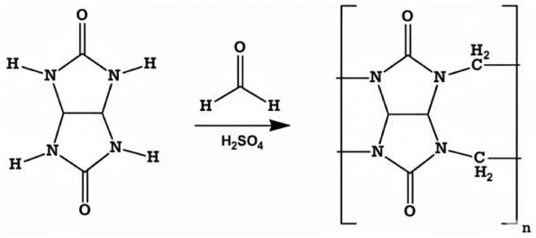
Figure 1. Schematic representation of CB[n] synthesis, where n = 6, 7, 8.

After cooling to room temperature, the reaction mixture was concentrated to dryness. The resulting solid was ground to a fine powder and suspended in distilled water (150–200 mL), followed by stirring at room temperature for 24 h. The suspension was filtered to afford aqueous extract 1. The remaining solid residue was resuspended in distilled water (150–200 mL) and stirred at 40 ◦C for 24 h. After filtration, aqueous extract 2 and an insoluble residue (Residue 1) were obtained. Aqueous extracts 1 and 2 were combined and concentrated under reduced pressure to a final volume of 10–15 mL to yield a concentrated CB[n] solution.

https://doi.org/10.3390/jcs10050255

Isolation of CB[7]. Methanol (80 mL) was added to the concentrated CB[n] solution, and the mixture was stirred at room temperature for 24 h. The precipitated solid was collected by filtration and dried in a vacuum oven at 60 ◦C for 12 h to obtain CB[7] as a white crystalline powder.
Isolation of CB[8]. The previously obtained insoluble residue (Residue 1) was treated with 40% formic acid (15 mL) under stirring. After dissolution of the acid-soluble fraction, the mixture was filtered. The undissolved solid was collected (Residue 2), while the filtrate was retained for further processing. Residue 2 was recrystallized from concentrated hydrochloric acid to yield crystalline CB[8].
Isolation of CB[6]. The filtrate obtained from the formic acid treatment (vide supra) was evaporated to dryness. The resulting solid was washed with distilled water (20 mL) and subsequently recrystallized from 8 M HCl to produce crystalline CB[6].
The identities and structural integrity of CB[6], CB[7], and CB[8] were confirmed by comparison of their Powder X-Ray Diffraction (PXRD) patterns with reference data from the Cambridge Crystallographic Data Centre (CCDC): CB[6] (CCDC 7209204), CB[7] (CCDC 1428201), and CB[8] (CCDC 883371). The diffraction patterns (Figures S1–S3) were consistent with previously reported data [27,28].
  - Synthesis and Surface Functionalization of Mesoporous Bioactive Glass
Mesoporous bioactive glass (MBG) nanoparticles were synthesized via a sol–gel method using tetraethyl orthosilicate (TEOS) as the silica source, calcium nitrate, and triethyl phosphate in an acidic aqueous medium with Pluronic P123 as a structure-directing agent. The mixture was aged at 40 ◦C for 48 h, dried, and calcined at 600 ◦C for 5 h to remove the template and obtain the final porous structure.
Preparation of MBGs@CB[6]. CB[6] (50 mg) was dissolved in distilled water (75 mL) containing 3 M HCl (15 mL) under vigorous stirring. MBGs (50 mg) were added to the solution, and the suspension was stirred at 60 ◦C for 3 h. The temperature was subsequently increased to 80 ◦C and maintained for 5 h to promote partial solvent evaporation and the removal of water and hydrochloric acid. When the total volume was reduced to approximately 10 mL, the suspension was transferred to a Petri dish and dried under vacuum (100 mbar) at 60 ◦C for 24 h to constant weight, affording the composite material MBGs@CB[6].
Preparation of MBGs@CB[7]. CB[7] (50 mg) was dissolved in distilled water (25 mL) under vigorous stirring at room temperature. MBGs (50 mg) were added to the solution, and the mixture was stirred at 60 ◦C for 3 h. The temperature was then increased to 80 ◦C and maintained for 2 h to partially evaporate the solvent to a final volume of approximately 10 mL. The resulting suspension was transferred to a Petri dish and dried under vacuum at 60 ◦C overnight to constant weight, yielding MBGs@CB[7].
Preparation of MBGs@CB[8]. CB[8] (50 mg) was dissolved in deionized water (350 mL) at 60 ◦C under stirring for 1.5 h. MBGs (50 mg) were subsequently added, and the mixture was stirred at 60 ◦C for 3 h. The temperature was increased to 85 ◦C and maintained for 12 h to reduce the solvent volume to approximately 10 mL. The concentrated suspension was transferred to a Petri dish and dried under vacuum at 60 ◦C for 24 h to constant weight, affording MBGs@CB[8].
  - Characterization Methods
Fourier transform infrared (FTIR) spectra were recorded using a Nicolet 6700 spectrometer (Thermo Fisher Scientific, Waltham, MA, USA) equipped with an attenuated total reflectance (ATR) accessory. Spectra were collected in the range 400–4000 cm−1 with a

https://doi.org/10.3390/jcs10050255

spectral resolution of 4 cm−1 and 32 accumulated scans. Reflectance data were converted to absorbance using the Kubelka–Munk transformation.
Morphological analysis was performed using a QUANTA 200 3D scanning electron microscope (SEM) (FEI, Hillsboro, OR, USA) operated in environmental or reduced vacuum mode. Images were acquired at accelerating voltages between 5 and 30 kV, depending on the sample and imaging requirements. Prior to analysis, samples were mounted on aluminum stubs and sputter-coated with a thin conductive layer when necessary.
Powder X-ray diffraction (PXRD) patterns of crystalline CB[6], CB[7], and CB[8] were recorded using an XRD-7000 diffractometer (Shimadzu, Kyoto, Japan) equipped with a Cu Kα radiation source (λ = 1.5406 Å). Data were collected in the 2θ range of 5–50◦ at a scan
rate of 30◦ min−1. Phase identification was performed by comparison with reference data
from the CCDC.
Thermogravimetric analysis (TGA) was carried out using an STA 449 F1 Jupiter instrument (NETZSCH, Selb, Germany). Approximately 5 mg of sample was placed in an alumina crucible and heated from 25 ◦C to 600 ◦C at a rate of 10 ◦C min−1. Measurements were conducted under a controlled gas flow (air or argon, 80 and 20 mL min−1, respectively).
  - Nitrogen Adsorption–Desorption Analysis
Textural properties, including specific surface area and pore size distribution, were determined by low-temperature nitrogen adsorption–desorption measurements at −196 ◦C using a 3Flex surface characterization analyzer (Micromeritics, Norcross, GA, USA). Prior to analysis, approximately 100 mg of each sample was degassed under vacuum at 100 ◦C for 2 h until constant weight was achieved.
The specific surface area (S-BET) was calculated using the Brunauer–Emmett–Teller (BET) method by linear fitting of the adsorption isotherm in the relative pressure (P/P₀) range of 0.05–0.30. The pore size distribution was determined from the adsorption branch using the Barrett–Joyner–Halenda (BJH) model. The total pore volume was estimated from the amount of nitrogen adsorbed at a relative pressure of P/P₀ ≈ 0.995.
  - Molecular Mechanics Calculation of CB[n]-SiO₂ Surface Interactions
Molecular mechanics calculations were performed using HyperChem 7.5 (Hypercube Inc., Gainesville, FL, USA) employing the MM+ force field. The SiO₂ surface was modeled using an α-quartz crystal structure constructed from a 3 × 3 × 3 supercell derived from crystallographic unit cell parameters. Periodicity was not applied; the model represented a finite slab. Prior to adsorption simulations, the geometries of CB[6], CB[7], and CB[8] were fully optimized using the MM+ force field until the root-mean-square (RMS) gradient convergence criterion reached 0.01 kcal mol−1 Å−1.
Interaction energies between CB[n] and the SiO₂ surface were calculated under the following assumptions: (i) adsorption of cucurbit[n]uril does not induce structural changes in the SiO₂ surface (rigid surface approximation); (ii) no intermolecular interactions occur between adjacent CB[n] molecules (single-molecule adsorption model); and (iii) solvent effects are neglected (gas-phase approximation).
The interaction energy was determined using Equation (1):
Einteraction = Eadsorption − Edeformation (1) where E_{adsorption} is the total energy of the CB[n]-SiO₂ adsorption complex, E_{deformation}
represents the strain energy of the CB[n] molecule upon adsorption.

https://doi.org/10.3390/jcs10050255

The deformation energy was calculated as:

Edeformation = EadsorbedCB[n] − EoptimizedCB[n] (2)

where E_{adsorbedCB[n]} is the energy of the CB[n] molecule in the adsorbed geometry, E_{optimizedCB[n]} denotes the energy of the fully optimized isolated CB[n] molecule. All reported energies are given in kcal mol−1.

Results and Discussion
  - Rationale for CB[n] Deposition Strategy
Previous studies have demonstrated that the deposition behavior of cucurbit[n]urils (CB[n], n = 6–8) on porous inorganic substrates strongly depends on their solubility and supramolecular association in aqueous media. In particular, deposition on hydroxyapatite revealed that CB[6] and CB[8] tend to form surface aggregates, whereas the higher water solubility of CB[7] facilitates its penetration into the porous scaffold [28]. Subsequent investigations showed that controlled heating of aqueous CB[6] solutions promotes the formation of water-associated supramolecular aggregates, enabling uniform surface coverage of hydroxyapatite and titanium nickelide substrates [17,27].
These findings indicate that aqueous-phase deposition combined with gradual solvent evaporation provides an effective route for achieving controlled surface modification of porous inorganic materials without the use of organic solvents. Such an approach is particularly attractive for biomaterial applications, as it minimizes potential alterations of surface bioactivity and avoids solvent-induced structural changes.
Considering the established bioactivity and ion-release properties of bioactive glasses and MBGs [3–5,23,24], we adopted a similar aqueous deposition strategy for MBG modification. CB[n] was introduced from aqueous solution followed by controlled thermal evaporation at elevated temperature to promote adsorption and surface organization within the mesoporous framework (see Section 2.2).
  - FTIR Analysis of MBGs@CB[n] Composites
The successful incorporation of cucurbit[n]urils into the MBG framework was evaluated by FTIR spectroscopy (Figure 2). The spectrum of pristine MBGs is characterized by broad Si–O–Si asymmetric stretching vibrations in the 1040–1100 cm−1 region, accompanied by symmetric stretching and bending modes near 800 cm−1 and 460 cm−1, respectively. These bands remain present in all modified samples, confirming preservation of the silicate network after surface functionalization.
In the FTIR spectrum of MBGs@CB[6] (Figure 2a), additional absorption bands characteristic of CB[6] are clearly observed. A prominent band at 1726 cm−1 is assigned to the stretching vibration of the carbonyl (C=O) groups located at the glycoluril portals. Furthermore, bands in the 1200–1500 cm−1 region correspond to methylene (–CH₂–) bending vibrations of the macrocyclic framework. Compared to pure CB[6], a slight red shift (~2 cm−1) of the carbonyl band is observed upon adsorption onto MBGs, accompanied by a decrease in CH₂ band intensity. The small red shift suggests the involvement of portal carbonyl groups in weak hydrogen bonding interactions with surface silanol (Si–OH) groups of the BG.
For MBGs@CB[7] (Figure 2b), similar vibrational features are detected; however, the carbonyl stretching band appears at 1694 cm−1. Relative to pure CB[7], a pronounced blue shift of approximately 34 cm−1 is observed. The substantial blue shift observed for CB[7] (~34 cm−1) suggests a significant perturbation of the carbonyl group environment, which may indicate stronger hydrogen bonding or coordination-type interactions with surface

https://doi.org/10.3390/jcs10050255

silanol groups. However, alternative contributions from changes in molecular packing, local polarity, or confinement effects within the mesopores cannot be excluded. Therefore, the FTIR data should be interpreted as complementary evidence alongside the BET, TGA, and molecular modeling results, rather than as definitive proof of interaction strength. The magnitude of this shift implies that CB[7] exhibits the strongest interaction with the MBG surface among the three homologues.
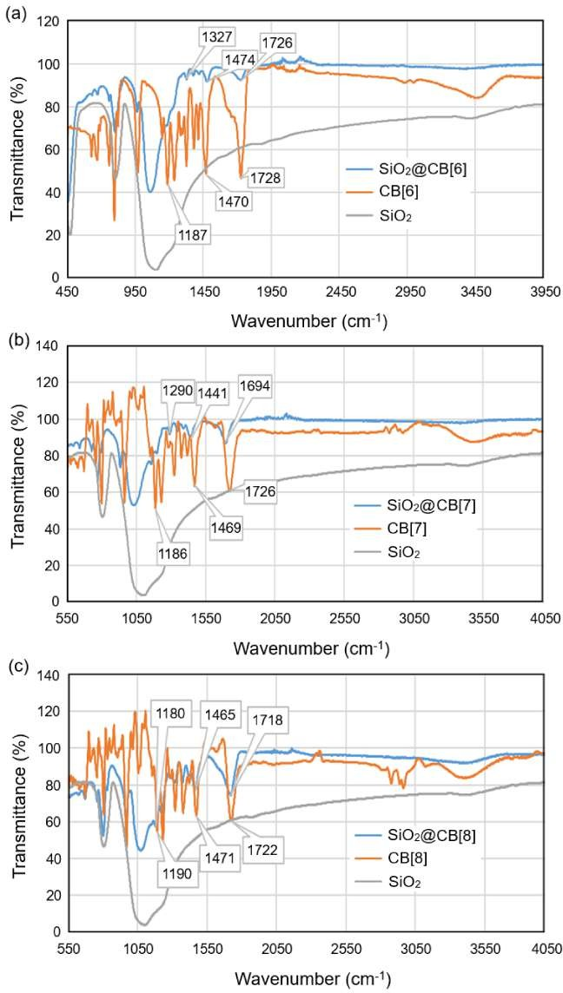
Figure 2. Comparative FTIR spectra of (a) CB[6], (b) CB[7], and (c) CB[8] (orange lines), pristine MBGs (gray lines), and the corresponding MBGs@CB[n] (blue lines) composites. Characteristic stretching vibrations of the cucurbit[n]urils and Si–O–Si framework bands of the mesoporous bioactive glass are highlighted.

https://doi.org/10.3390/jcs10050255

Figure 2c also shows characteristic carbonyl and methylene vibrations of the macrocycle for the FTIR spectrum of MBGs@CB[8]. The C=O stretching band appears at 1726 cm−1, with a modest blue shift of approximately 4 cm−1 compared to pure CB[8]. This smaller shift indicates weaker or less specific interfacial interactions relative to CB[7], which may arise from steric limitations associated with the larger cavity size of CB[8], restricting optimal surface contact within the mesoporous channels.
A comparative analysis of the carbonyl band shifts reveals a size-dependent and non-linear interaction trend: CB[6] exhibits a slight red shift (~2 cm−1), CB[7] shows a pronounced blue shift (~34 cm−1), whereas CB[8] displays a moderate blue shift (~4 cm−1). The magnitude and direction of these shifts reflect differences in the electronic environment of the portal carbonyl groups upon adsorption. The substantial blue shift observed for CB[7] suggests a significant perturbation of the C=O bond, indicative of stronger interfacial interactions with surface silanol groups of the MBG. This behavior implies that CB[7] achieves the most favorable geometric and electronic compatibility with the MBG surface, potentially enabling more effective alignment and interaction within the mesoporous framework compared to CB[6] and CB[8].
  - Surface Morphology Analysis
The surface morphology of pristine MBGs and the corresponding MBGs@CB[n] composites was examined in detail using SEM. As shown in Figure S4, the pristine MBGs sample consists of irregularly shaped conglomerates with dimensions of approximately 20–50 µm. These larger aggregates are composed of densely packed nanoscale primary particles, typical of sol–gel-derived mesoporous bioactive glasses. The observed morphology reflects partial aggregation during drying and calcination processes.
Upon modification with CB[6], the overall conglomerate morphology of MBGs is preserved; however, the surface becomes decorated with smaller particles in the range of 570–900 nm (Figure 3a,b). These nanoscale domains are distributed across the MBG aggregates, suggesting deposition of CB[6] on the external surface and possibly within accessible mesopores. The relatively uniform distribution indicates effective adsorption of the macrocycle under the applied deposition conditions.
In the case of MBGs@CB[7], conglomerates are again observed; however, finely dispersed particles ranging from 700 nm to 3 µm are more clearly distinguishable on the aggregate surfaces as depicted in Figure 3c,d. Compared to MBGs@CB[6], the particles
in MBGs@CB[7] appear less prone to secondary aggregation, and interparticle boundaries are more clearly defined. This behavior may be attributed to differences in solubility and interaction strength of CB[7], which could promote more homogeneous surface coverage and reduced interparticle cohesion.
SEM images of MBGs@CB[8] display a similar overall morphology (Figure 3e,f). Large MBG conglomerates are present, decorated with dispersed particles in the range of 600 nm to 2 µm. The distribution appears somewhat less uniform compared to MBGs@CB[7],
which may reflect steric effects associated with the larger cavity size of CB[8] influencing
its deposition and surface organization.
Importantly, no evidence of structural collapse or significant morphological degradation of the MBG framework is observed after modification with any of the cucurbit[n]urils. The preservation of aggregate morphology indicates that the aqueous deposition and thermal evaporation procedure does not adversely affect the structural integrity of the MBG.

https://doi.org/10.3390/jcs10050255

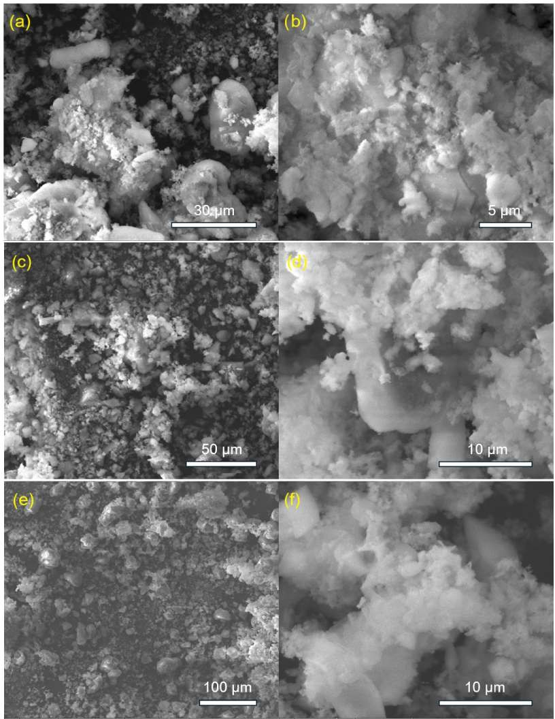
Figure 3. SEM images of MBGs@CB[n] composites at different magnifications: MBGs@CB[6] at 3052× (a) and 11,000× (b); MBGs@CB[7] at 600× (c) and 10,000× (d); and MBGs@CB[8] at 600× (e)
and 10,000× (f). The images illustrate the aggregate morphology of mesoporous bioactive glass and
the surface distribution of CB[n]-modified particles.
  - Textural Properties and Porosity Analysis
The textural parameters of pristine MBGs and the corresponding MBGs@CB[n] composites, including specific surface area, micropore and mesopore surface areas, and pore volumes, are summarized in Table 1.
Pristine MBGs exhibit a specific surface area of 111.66 m2 g−1, reflecting the presence
of a developed mesoporous network. Upon functionalization with cucurbit[n]urils, a substantial reduction in textural parameters is observed, confirming successful incorporation of macrocycles within the porous framework.

https://doi.org/10.3390/jcs10050255

Table 1. Comparative textural characteristics of pristine MBGs and MBGs modified with CB[6], CB[7], and CB[8], including specific surface area (BET), micropore and mesopore surface areas, and pore volumes.

Sample | BET Surface Area, m2 g−1 | Micropore Area, m2 g−1 | Micropore Area (BJH Adsorption), m2 g−1 | Micropore Volume, cm3 g−1 | Total Pore Volume, cm3 g−1
MBGs | 111.66 | 16.75 | 92.8 | 0.0061 | 0.42
MBGs@CB[6] | 40.25 | 7.95 | 33.3 | 0.0029 | 0.20
MBGs@CB[7] | 8.48 | 12.99 | 3.9 | 0.0047 | 0.03
MBGs@CB[8] | 32.13 | 14.49 | 18.2 | 0.0059 | 0.13

Modification with CB[6] results in a 64% reduction in specific surface area relative to pristine MBGs. The micropore and mesopore surface areas decrease by 52.5% and 64.1%, respectively, accompanied by reductions in micropore and mesopore volumes of 52.5% and 52.4%. These results indicate partial occupation of both micro- and mesopores. The relatively uniform decrease across pore types suggests that CB[6], due to its compact size, can access and distribute within the porous network without completely blocking the mesostructure.
In contrast, MBGs@CB[7] exhibits a dramatic reduction in specific surface area to 8.48 m2 g−1 (92.4% decrease), representing the most pronounced textural change among the studied samples. While the micropore area decreases moderately (22.4%), the mesopore area decreases by ~96% (from 92.8 to 3.9 m2/g), and the total pore volume is
reduced by 92.9%. This pronounced loss of mesoporosity indicates extensive pore filling and/or blockage by CB[7]. The data suggest that CB[7] exhibits strong affinity toward the mesoporous channels, likely due to optimal molecular dimensions and favorable surface interactions, consistent with the pronounced FTIR carbonyl shift observed for this homolog. The MBGs@CB[8] composite shows a 71.2% reduction in specific surface area
(32.13 m2 g−1), which is intermediate between CB[6] and CB[7]. The mesopore surface
area decreases significantly (80.4%), whereas the micropore area is reduced by only 13.5%. Notably, the micropore volume remains nearly unchanged (3.3% decrease relative to pristine MBGs), while the total pore volume decreases by 69%. This behavior suggests that CB[8] preferentially interacts with mesopores without substantially affecting microporous domains, likely due to steric constraints associated with its larger cavity size.
  - Thermal Stability and Loading Analysis
To evaluate the loading content of cucurbit[n]urils within the MBG framework and to assess their thermal stability, TGA coupled with differential scanning calorimetry (DSC) was performed for all MBGs@CB[n] samples.
The TGA curve of MBGs@CB[6] shows a total mass loss of 32.7% over the investigated temperature range (Figure 4a). The remaining 67.3% residue corresponds primarily to the inorganic silicate matrix. The observed mass loss is attributed to thermal decomposition of the incorporated CB[6], confirming successful loading of the macrocycle. The relatively gradual decomposition profile and substantial residual mass indicate stable retention of CB[6] within the mesoporous structure. These results are consistent with FTIR observations suggesting interfacial interactions between CB[6] and surface silanol groups.
In contrast, MBGs@CB[7] exhibits a significantly higher mass loss of 54.7%, leaving a residual mass of 45.34%, as presented in Figure 4b. This pronounced weight reduction indicates a higher apparent organic content or a greater extent of thermally removable species. The sharper mass loss event observed in the DTG curve suggests that CB[7] is more readily decomposed or released upon heating. While BET analysis indicated

https://doi.org/10.3390/jcs10050255

extensive pore occupation by CB[7], the thermal data suggest that its interaction with the silicate framework may involve a larger fraction of physically confined rather than strongly anchored molecules. This behavior correlates with the significant structural changes observed in the porosity analysis.
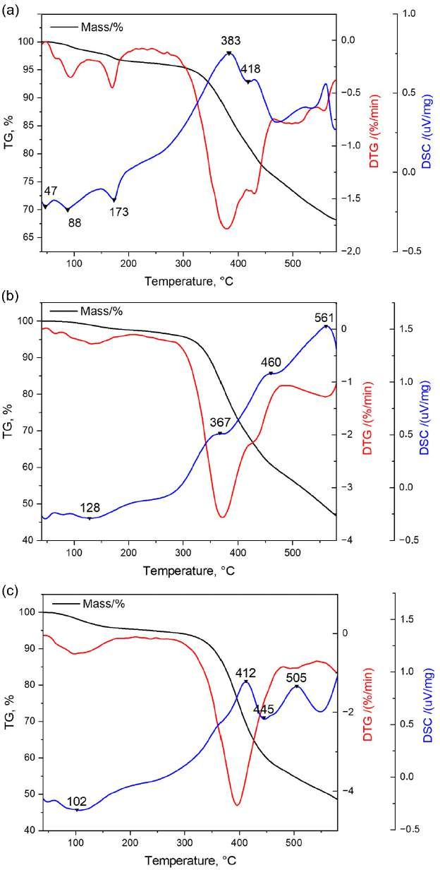
Figure 4. TGA and DSC curves of (a) MBGs@CB[6], (b) MBGs@CB[7], and (c) MBGs@CB[8] composites, illustrating the thermal decomposition behavior and relative loading of cucurbit[n]urils within the mesoporous bioactive glass framework.

https://doi.org/10.3390/jcs10050255

Figure 4c displays a total mass loss of 53.9%, comparable to MBGs@CB[7] for the MBGs@CB[8] composite, with a residual mass of 46.14%. However, the DTG peak maximum is shifted toward higher temperatures (up to ~395 ◦C), indicating enhanced thermal stability relative to CB[7]. This shift suggests stronger or more stable confinement of CB[8] within the porous network. Combined with the BET results showing preserved microporosity, this behavior supports a model in which CB[8] is distributed both on the surface and within mesopores, achieving effective embedding without complete pore blockage.
The combined analysis of SEM, BET, FTIR, and TGA results reveals a size-dependent interaction pattern between cucurbit[n]urils and the MBG framework:
- CB[6]: Moderate loading with stable retention and partial pore occupation.
- CB[7]: Extensive mesopore filling with high apparent loading but lower thermal
stability, suggesting a significant fraction of physically confined species.
- CB[8]: High loading with improved thermal stability and balanced preservation of pore structure.
These findings demonstrate that the interaction between CB[n] homologues and mesoporous bioactive glass is governed by macrocycle size and geometric compatibility with the pore architecture. Among the investigated systems, CB[8] appears to provide the most favorable compromise between loading efficiency, structural preservation, and thermal stability.
  - Molecular Modeling of CB[n]-SiO₂ Surface Interactions
To gain mechanistic insight into the experimentally observed size-dependent behavior, molecular mechanics calculations were performed to model the interaction of cucurbit[n]urils with a representative silica surface. An α-quartz SiO₂ unit cell was selected as a simplified surface model, and two orientations of CB[n] relative to the surface were considered: perpendicular (⊥) and parallel ( ) (Figure 5). While other tilted orientations are theoretically possible, they would yield interaction energies intermediate between the perpendicular and parallel extremes and would not affect the qualitative ranking of CB[n] surface affinity. Therefore, the two limiting cases (⊥ and ) are sufficient for the purpose of supporting the experimental trends. Computational simulations were performed under the assumptions detailed in Section 2.5.
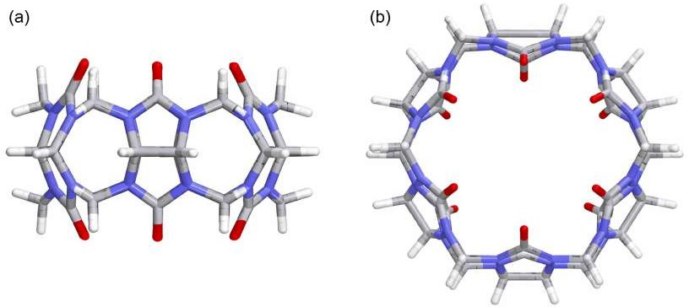
Figure 5. Schematic representation of the relative orientation of CB[n] molecules, (a) perpendicular (⊥) and (b) parallel ( ), considered for adsorption on the SiO₂ surface.
It should be noted that the calculations were performed under several simplifying assumptions, which limit their direct quantitative interpretation. The α-quartz model represents an idealized surface and does not fully capture the structural heterogeneity

https://doi.org/10.3390/jcs10050255

of real MBG (e.g., defects, pore curvature, varying silanol density). The rigid surface approximation, gas-phase conditions, and single-molecule adsorption model neglect solvent effects, confinement effects, and intermolecular interactions between adjacent CB[n] molecules within the pores. Therefore, the calculated interaction energies should be considered as qualitative trends supporting the experimental observations rather than as quantitative predictions.
For CB[6], the most favorable interaction was observed in the perpendicular orientation, as shown in Figure 6a, with an interaction energy of −31.45 kcal mol−1 (Table 2). This orientation enables optimal alignment of the portal carbonyl groups
toward surface silanol sites, promoting favorable electrostatic and hydrogen-bonding interactions compared to the parallel configuration (Figure 6b). The calculated interaction energy is consistent with the moderate pore occupation and stable thermal behavior observed experimentally.
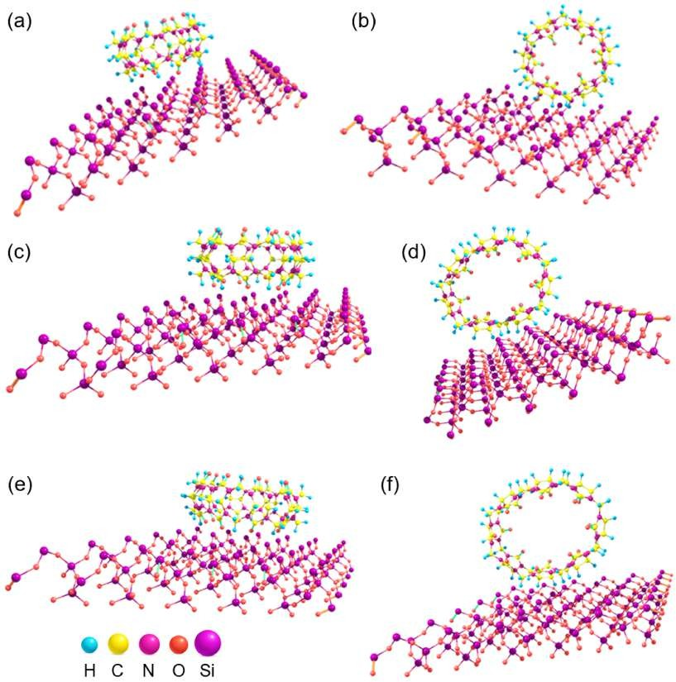
Figure 6. Optimized adsorption geometries obtained from molecular mechanics calculations for the interaction of cucurbit[n]urils with the α-quartz (SiO₂) surface: (a,b) CB[6], (c,d) CB[7], and (e,f) CB[8] in perpendicular (⊥) and parallel ( ) adsorption orientations, respectively. Individual elements are represented by colored spheres (H, C, N, O, Si) for clarity.

https://doi.org/10.3390/jcs10050255

Table 2. Calculated adsorption, deformation, and interaction energies (kcal·mol−1) for CB[6], CB[7], and CB[8] on the α-quartz (SiO₂) surface in perpendicular (⊥) and parallel ( ) orientations.

Adsorption Orientations
⊥
Sample | Energy, kcal mol−1 | Perpendicular ( ) | Parallel ( )
 | Eadsorption | −27.80 | −19.61
CB[6] | Edeformation | 3.65 | 0.77
 | Einteraction | −31.45 | −20.38
 | Eadsorption | −32.96 | −19.85
CB[7] | Edeformation | 2.18 | 2.05
 | Einteraction | −35.14 | −21.91
 | Eadsorption | −34.14 | −22.12
CB[8] | Edeformation | 0.41 | 0.58
 | Einteraction | −34.5 | −22.70

Among the investigated homologues, CB[7] exhibited the strongest calculated interaction energy in perpendicular orientation (−35.14 kcal mol−1), as shown in Figure 6c. This result indicates a highly favorable electronic interaction between CB[7] and the silica surface at the molecular level. However, despite the high interaction energy, experimental data (TGA and BET) suggest partial instability or extensive pore blocking in the composite system. This apparent discrepancy may arise from steric constraints and packing effects within the mesoporous network, which are not fully captured in the isolated surface model. Thus, while CB[7] demonstrates strong intrinsic surface affinity, its larger effective footprint within confined pores may reduce practical stability under thermal treatment.
A similarly favorable interaction energy was calculated in the perpendicular orientation for CB[8], as shown in Figure 6e. Notably, the deformation (strain) energy of CB[8] upon adsorption was lower than that of CB[6] and CB[7], indicating reduced structural distortion during surface association. This suggests that CB[8] may achieve a more stable adsorption configuration, consistent with the observed DTG peak shift toward higher temperatures and the preservation of microporosity in BET analysis.
In line with prior simulation studies highlighting the role of composition in governing atomic-level flexibility in bioactive glasses [40], the present results further emphasize that molecular-scale interactions and geometric compatibility are key factors controlling interfacial stability and structural response in hybrid systems.
The computational results support the experimentally observed size-dependent interaction trend. While CB[7] exhibits the strongest intrinsic interaction energy, CB[8] appears to achieve a more favorable balance between adsorption energy and structural stability, due to lower deformation penalties and reduced steric strain within the porous framework. This balance may explain the improved thermal stability and partial preservation of porosity observed for MBGs@CB[8]. Overall, the modeling results reinforce the conclusion that macrocycle size and geometric compatibility play a critical role in governing the interfacial behavior of cucurbit[n]urils within mesoporous bioactive glass systems.

Conclusions
In this study, mesoporous bioactive glass composites functionalized with cucurbit[n]urils (CB[6], CB[7], and CB[8]) were successfully synthesized via aqueous deposition followed

https://doi.org/10.3390/jcs10050255

by controlled solvent evaporation. FTIR spectroscopy confirmed the incorporation of macrocycles and revealed size-dependent carbonyl shifts, with the most pronounced perturbation observed for CB[7]. Nitrogen sorption analysis demonstrated that CB[6] caused moderate pore occupation (64% surface area reduction), CB[7] induced extensive mesopore blockage (92.4% reduction), while CB[8] preserved microporosity almost unchanged (only 3.3% decrease). TGA showed comparable loading for CB[7] and CB[8], yet MBGs@CB[8] exhibited enhanced thermal stability, with the DTG maximum shifted to
~395 ◦C. Molecular modeling supported these findings, indicating favorable adsorption
geometry for all homologues. Collectively, CB[8] provides the most balanced combination of pore preservation, loading efficiency, and thermal stability, making it the most promising candidate for further functionalization in drug delivery and bone-regenerative applications.

Supplementary Materials: The following supporting information can be downloaded at: https:
//www.mdpi.com/article/10.3390/jcs10050255/s1, Figure S1. PXRD pattern of CB[6]; Figure S2. PXRD pattern of CB[7]; Figure S3. PXRD pattern of CB[8]; Figure S4. SEM images of the pristine MBGs sample.
Author Contributions: Conceptualization, G.Z., A.B. and R.Y.; methodology, G.Z., A.U., I.K. and R.R.; software, M.S. and A.K.; validation, A.U., S.M., M.S., A.K., R.R. and R.Y.; formal analysis,
A.B.; investigation, G.Z., A.U. and I.K.; resources, S.M.; data curation, G.Z., A.U., S.M. and M.S.; writing—original draft preparation, G.Z.; writing—review and editing, G.Z., A.U., S.M., M.S., A.K., A.B., I.K., R.R. and R.Y.; visualization, S.M., M.S., A.K., I.K. and R.R.; supervision, A.B. and R.Y.; project administration, R.Y.; funding acquisition, A.B. All authors have read and agreed to the published manuscript.
Funding: This work was supported by Russian Science Foundation, grant RSF 24-43-20044 (to IK).
Data Availability Statement: The original contributions presented in this study are included in the article/Supplementary Material. Further inquiries can be directed to the corresponding author.
Acknowledgments: The authors express their gratitude to the L.N. Gumilyov Eurasian National University and National Research Tomsk State University for providing laboratory facilities and technical support during the research.
Conflicts of Interest: The authors declare no conflicts of interest.

References
- Deanesly, R.; Parkes, A.S. Oestrogenic Action of Compounds of the Androsterone-Testosterone Series. BMJ 1936, 1, 257–258. [CrossRef] [PubMed]
- Amato, S.F.; Ezzell, R.M. Regulatory Affairs for Biomaterials and Medical Devices; Elsevier: Amsterdam, The Netherlands, 2015.
- Gorustovich, A.A.; Roether, J.A.; Boccaccini, A.R. Effect of Bioactive Glasses on Angiogenesis: A Review of In Vitro and In Vivo Evidences. Tissue Eng. Part B Rev. 2010, 16, 199–207. [CrossRef] [PubMed]
- Hench, L.L.; Hench, J.W.; Greenspan, D. Bioglass: A short history and bibliography. J. Aust. Ceram. Soc. 2004, 40, 1–42.
- Nandi, S.K.; Mahato, A.; Kundu, B.; Mukherjee, P. Doped Bioactive Glass Materials in Bone Regeneration. In Advanced Techniques in Bone Regeneration; Zorzi, A.R., de Miranda, J.B., Eds.; IntechOpen: London, UK, 2016; pp. 275–328.
- Hench, L.L. The story of Bioglass®. J. Mater. Sci. Mater. Med. 2006, 17, 967–978. [CrossRef]
- Hench, L.L. Bioceramics. J. Am. Ceram. Soc. 1998, 81, 1705–1728. [CrossRef]
- Vallet-Regí, M.; Ragel, C.V.; Salinas, A.J. Glasses with Medical Applications. Eur. J. Inorg. Chem. 2003, 2003, 1029–1042. [CrossRef]
- Li, R.; Clark, A.E.; Hench, L.L. An investigation of bioactive glass powders by sol-gel processing. J. Appl. Biomater. 1991, 2, 231–239. [CrossRef]
- Ylänen, H.O. Clinical application of bioactive glasses. In Bioceramics and Their Clinical Applications; Kokubo, T., Ed.; Woodhead Publishing: Cambridge, UK, 2008; pp. 571–582.
- Jones, J.R. Review of bioactive glass: From Hench to hybrids. Acta Biomater. 2013, 9, 4457–4486. [CrossRef]
- Vallet-Regí, M.; González-Calbet, J.M. Calcium phosphates as substitution of bone tissues. Prog. Solid State Chem. 2004, 32, 1–31. [CrossRef]

https://doi.org/10.3390/jcs10050255

- Rondinella, A.; Marin, E.; McEntire, B.; Bock, R.; Bal, B.S.; Zhu, W.L.; Yamamoto, K.; Pezzotti, G. Bioceramics are Not Bioinert: The Role of Oxide and Non-Oxide Bioceramics on the Oxidation of UHMWPE Components in Artificial Joints. Key Eng. Mater. 2018, 782, 165–175. [CrossRef]
- Best, S.M.; Porter, A.E.; Thian, E.S.; Huang, J. Bioceramics: Past, present and for the future. J. Eur. Ceram. Soc. 2008, 28, 1319–1327. [CrossRef]
- Lin, K.; Wu, C.; Chang, J. Advances in synthesis of calcium phosphate crystals with controlled size and shape. Acta Biomater. 2014, 10, 4071–4102. [CrossRef] [PubMed]
- Vallet-Regí, M.; Ruiz-Hernández, E. Bioceramics: From Bone Regeneration to Cancer Nanomedicine. Adv. Mater. 2011, 23, 5177–5218. [CrossRef] [PubMed]
- Marchenko, E.; Luchsheva, V.; Baigonakova, G.; Bakibaev, A.; Vorozhtsov, A. Functionalization of the Surface of Porous Nickel–Titanium Alloy with Macrocyclic Compounds. Materials 2022, 16, 66. [CrossRef]
- Kolesnichenko, I.V.; Anslyn, E.V. Practical applications of supramolecular chemistry. Chem. Soc. Rev. 2017, 46, 2385–2390. [CrossRef] [PubMed]
- Arcos, D.; Portolés, M.T. Mesoporous Bioactive Nanoparticles for Bone Tissue Applications. Int. J. Mol. Sci. 2023, 24, 3249. [CrossRef]
- Vulpoi, A.; Botiz, I. Mesoporous Bioactive Glasses: A Review on Structure-Directing-Based Synthesis, Characterization, and Biomedical Applications. Materials 2026, 19, 876. [CrossRef]
- Langer, R. Drug delivery. Drugs on target. Science 2001, 293, 58–59. [CrossRef]
- Deanesly, R.; Parkes, A.S. Testosterone. Br. Med. J. 1936, 1, 527–528. [CrossRef]
- Hench, L.L.; Jones, J.R. Bioactive Glasses: Frontiers and Challenges. Front. Bioeng. Biotechnol. 2015, 3, 194. [CrossRef]
- Buser, D.; Weber, H.; Lang, N.P. Tissue integration of non-submerged implants. l-year results of a prospective study with 100 ITI hollow-cylinder and hollow-screw implants. Clin. Oral Implant. Res. 1990, 1, 33–40. [CrossRef]
- El-Rashidy, A.A.; Roether, J.A.; Harhaus, L.; Kneser, U.; Boccaccini, A.R. Regenerating bone with bioactive glass scaffolds: A review of in vivo studies in bone defect models. Acta Biomater. 2017, 62, 1–28. [CrossRef]
- Aleškovic´, M.; Šekutor, M. Overcoming barriers with non-covalent interactions: Supramolecular recognition of adamantyl cucurbit[n]uril assemblies for medical applications. RSC Med. Chem. 2023, 15, 433–471. [CrossRef]
- Burkhanbayeva, T.; Ukhov, A.; Assylbekova, D.; Mussina, Z.; Kurzina, I.; Abilkasova, S.; Bakibaev, A.; Issabayeva, M.; Yerkassov, R.; Shaikhova, Z. The Role of Methods for Applying Cucurbit[6]uril to Hydroxyapatite for the Morphological Tuning of Its Surface in the Process of Obtaining Composite Materials. Materials 2024, 17, 4995. [CrossRef]
- Burkhanbayeva, T.; Ukhov, A.; Fedorishin, D.; Gubankov, A.; Kurzina, I.; Bakibaev, A.; Yerkassov, R.; Mashan, T.; Suyundikova, F.; Nurmukhanbetova, N.; et al. Development of New Composite Materials by Modifying the Surface of Porous Hydroxyapatite Using Cucurbit[n]urils. Materials 2024, 17, 2041. [CrossRef]
- Xie, X.; Li, X.; Luo, H.; Lu, H.; Chen, F.; Li, W. The Adsorption of Reactive Blue 19 Dye onto Cucurbit[8]uril and Cucurbit[6]uril: An Experimental and Theoretical Study. J. Phys. Chem. B 2016, 120, 4131–4142. [CrossRef]
- Li, X.; Xie, X.; Luo, H.; Li, L.; Li, Z.; Xue, Z.; Li, W. Adsorption of reactive yellow X-RG and reactive brilliant red X-3B onto cucurbit[8]uril and cucurbit[6]uril: Effect factors, adsorption behavior and mechanism study. J. Colloid Interface Sci. 2017, 498, 31–46. [CrossRef]
- Luo, H.; Huang, X.; Luo, Y.; Li, Z.; Li, L.; Gao, C.; Xiong, J.; Li, W. Adsorption behavior and mechanism of acidic blue 25 dye onto cucurbit[8]uril: A spectral and DFT study. Spectrochim. Acta Part A Mol. Biomol. Spectrosc. 2018, 193, 125–132. [CrossRef]
- Corda, E.; Hernandez, M.; Sanchez-Cortes, S.; Sevilla, P. Cucurbit[n]urils (n = 6–8) used as host molecules on supramolecular complexes formed with two different drugs: Emodin and indomethacin. Colloids Surf. A Physicochem. Eng. Asp. 2018, 227, 66–75. [CrossRef]
- Wu, X.; Zhang, Y.-M.; Liu, Y. Nanosupramolecular assembly of amphiphilic guest mediated by cucurbituril for doxorubicin delivery. RSC Adv. 2016, 6, 99729–99734. [CrossRef]
- Yu, G.; Chen, X. Host-Guest Chemistry in Supramolecular Theranostics. Theranostics 2019, 9, 3041–3074. [CrossRef]
- Wheate, N.J.; Buck, D.P.; Day, A.I.; Collins, J.G. Cucurbit[n]uril binding of platinum anticancer complexes. Dalton Trans. 2005, 3, 451–458. [CrossRef]
- Colaco, V.; Jadhav, S.R.; Bandi, S.P.; Datta, D.; Dhas, N.; Thakur, G.; Ramesh, B.V.; Alizadeh, B. Multifunctional Application of Supramolecular Cucurbiturils as Encapsulating Hosts in Drug Delivery: A Review. Int. J. Pharm. 2025, 681, 125801. [CrossRef]
- Fedorishin, D.A.; Mousanezhad, S.; Shapovalova, Y.G.; Kurzina, I.A.; Bakibaev, A.A. Biocompatibility of Cucurbit[n]urils. Chim. Techno Acta 2026, 13, 9216. [CrossRef]
- Ukhov, A.E.; Larikov, V.A.; Baigonakova, G.A.; Marchenko, E.S.; Gubonkov, A.; Bakibaev, A. Preparation of New Composite Materials Based on Urea-Containing Macrocyclic Compounds and Porous Titanium Nickelide. Vestn. Tomsk. Gos. Univ. Khimiya 2024, 36, 152–168. [CrossRef]

https://doi.org/10.3390/jcs10050255

- Kim, J.; Jung, I.-S.; Kim, S.-Y.; Lee, E.; Kang, J.-K.; Sakamoto, S.; Yamaguchi, K.; Kim, K. New Cucurbituril Homologues: Syntheses, Isolation, Characterization, and X-ray Crystal Structures of Cucurbit[n]uril (n = 5, 7, and 8). J. Am. Chem. Soc. 2000, 122, 540–541. [CrossRef]
- Tian, K.V.; Chass, G.A.; Di Tommaso, D. Simulations Reveal the Role of Composition into the Atomic-Level Flexibility of Bioactive Glass Cements. Phys. Chem. Chem. Phys. 2016, 18, 837–845. [CrossRef]

Disclaimer/Publisher’s Note: The statements, opinions and data contained in all publications are solely those of the individual author(s) and contributor(s) and not of MDPI and/or the editor(s). MDPI and/or the editor(s) disclaim responsibility for any injury to people or property resulting from any ideas, methods, instructions or products referred to in the content.

https://doi.org/10.3390/jcs10050255

